Retail Event

Health and Safety Pack

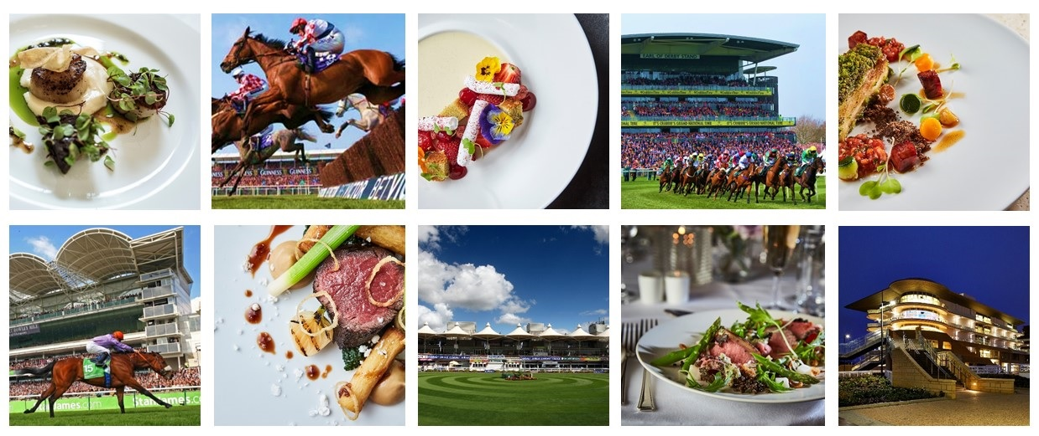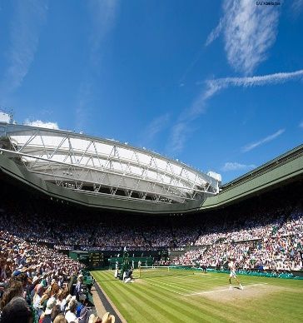

Unit Name:

Event Name:

Event Date:

Retail Area:

**THIS PAGE IS LEFT INTENTIONALLY BLANK**

**Retail Event Pack Contents and Instructions for Use**

|  |  |  |
| --- | --- | --- |
| **Document** | ***Instructions*** | **Page** |
| **Catering Cleaning Schedule** | *Provides guidance on cleaning within the unit* | **4** |
| **Briefing Checklist** | *Tailor and use to brief the team* | **5** |
| **Briefing Documents: Infection Control, Food Safety Discussion: Allergens, Essentials of Food Safety, Safe Systems of Work** | *Use to brief team* | **6-9** |
| **Employee Briefing Record** | *All staff to sign after briefing* | **10** |
| **Opening and Closing Checklist** | ***Opening Checklist*** *to be complete at the start of each day.* ***Closing Checklist*** *to be completed at the end of each day* | **11** |
| **Fridge Temperature Record** | *Record temperatures twice daily and keep the record within this pack* | **12** |
| **Food Service Temperature Record** | *Use to record temperature of hot food.* ***MUST*** *be documented at time of monitoring* | **13** |
| **Wastage Record Sheet** | *Complete at the end of the day, recording any wastage* | **14** |
| **Shortages List and Repairs Log** | *To record shortages and/or equipment faults* | **15** |
| **Event De-Brief Record** | *Manager to complete with feedback from the event* | **15** |

**Please return this completed pack to your manager.**

|  |  |  |  |  |
| --- | --- | --- | --- | --- |
| **CLEANING SCHEDULE** | | | | |
| **ITEM** | **PRODUCT** | **PPE REQUIRED** | **DOSE RATE** | **METHOD \*** |
| **Floors** | ***Multi EL10*** | Nitrile/Latex-free Gloves EN374* | 2 x 20ml pumps per 5l of warm water | Sweep up debris. Apply hot solution using clean mop or long handle scrubber, paying attention to floor/wall joint, around equipment, under and behind equipment. Rinse and mop over with fresh clean water. Allow to air dry. |
| **Work Surfaces** | ***Oasis Pro20 or Aseptopol*** | Nitrile/Latex-free Gloves EN374* | 20ml via dispenser per 600ml trigger spray | Remove debris. Apply sanitiser solution with a cloth or hand sprayer. Ensure that attention is given to legs and under edges. Wipe and then re-apply sanitiser and allow a 5-minute contact time. Wipe and Rinse and allow to air dry or dry with paper towels. |
| **Refrigerators / Freezers** | ***Oasis Pro20 or Aseptopol*** | Nitrile/Latex-free Gloves EN374* | 20ml via dispenser per 600ml trigger spray | Check and organise fridges daily. Check for spillages and wipe up [spillages should be wiped up immediately]. |
| **Hot Food Display Equipment** | ***Oasis Pro20 or Aseptopol*** | Nitrile/Latex-free Gloves EN374 | 20ml via dispenser per 600ml trigger spray | After use - switch off power supply and allow to cool. Remove containers and transfer to pan wash. Wash down all surfaces and rinse. Remove deposits from door runners with a stiff brush. Brush floor under appliance and clean up spillages. |
| **Temperature Probes** | ***Oasis Pro20, Aseptopol or Probe Wipes*** | Nitrile/Latex-free Gloves EN374* | 20ml via dispenser per 600ml trigger spray | Remove debris. Apply solution with a cloth or hand sprayer. Ensure that attention is given to the entire length of the probe needle, reapply solution and allow a 1-minute contact time. Rinse and allow to air dry or dry with paper towels. |
| **Sinks and Wash Hand Basins** | ***Oasis Pro 20 or Aseptopol*** | Nitrile/Latex-free Gloves EN374* | 20ml via dispenser per 600ml trigger spray | Clean with the general-purpose detergent. Remove any tide marks from the bowl and drainer with a scouring pad or cloth. Include taps, waste outlets and splash-backs in cleaning record. Rinse thoroughly with cold water. Apply sanitiser to all surfaces and leave to air dry. Ensure sufficient supply of towels and soap are maintained at the wash hand basin. |
| **Equipment Racks and Shelving** | ***Oasis Pro20 or Aseptopol*** | Nitrile/Latex-free Gloves EN374* | 20ml via dispenser per 600ml trigger spray | Remove stock and utensils/equipment from shelves and racking. Sweep debris off surfaces and sweep floor under. Clean with solution, rinse and allow to air dry. Replace stock and utensils/equipment. Ensure equipment is placed inverted as far as practicable. |
| **Waste Bins** | ***Multi EL10*** | Nitrile/Latex-free Gloves EN374* | 2 x 20ml pumps per 5l of warm water | Empty bins frequently throughout the day. Do not allow contents to overflow. Wash out empty bin or bin liner holder with solution. Clean external casing and the lid, paying attention to underside of lid and the handle [if fitted]. Rinse and allow to air dry. |

**SAFETY PRECAUTIONS**

* **Before cleaning electrical machinery ensure it is switched off and isolated from the mains.**
* **Before cleaning gas appliances ensure they are turned off. Take care when cleaning hot items.**
* **Follow all safety precautions shown in COSHH Product Task Cards for the cleaning product being used and always wear the correct PPE especially when handling or dispensing concentrated chemicals**

|  |  |  |
| --- | --- | --- |
|  | SAFETY BRIEFING CHECKLIST | |
| **Please Note: *This document should be amended to reflect actual practices and procedures at your site*** | | |
| **Unit Name:** | | **Date:** |
| **Function Name:** | | |
| **Briefing Information** | | |
| * **First Aid Arrangements** | You must report any accident to your supervisor / manager.  First aid facilities are available in the kitchens (1st Aid Box) | |
| * **Fire and Emergency** | Alarm sound is:  Exit by nearest fire exit.Assembly point is located at: | |
| * **Key Safety Behaviours** | **BE MINDFUL** – Always think first before you carry out a task or activity - are there any risks or hazards and is it safe to carry on. | |
| **GET INVOLVED** – Help your colleagues if they need it or if you see them in trouble. | |
| **SPEAK OUT** – If you are unsure of anything ask your manager/ supervisor or if you see any unsafe environments or working activities then let them know. | |
| * **Personal Protective Equipment (PPE)** | PPE such as waiters’ cloths, oven cloths, gloves and goggles, is provided to ensure risks to your safety are minimised. Ensure you use it. | |
| * **Manual Handling** | Ensure any manual handling tasks are within your capabilities and if you need assistance, please ask a member of the team or your supervisor/manager. Always use lifting aids, such as trolleys, sack trucks and keg barrows, where provided. | |
| * **Slips, Trips and Falls** | Ensure that any spillages are cleaned up immediately, keep walkways and working areas clear of obstructions, report any damaged floor surfaces to your supervisor/manager immediately and avoid running or rushing in your workplace. | |
| * **COSHH** | You must not use any chemicals unless you have been trained to do so. Ensure you always follow instructions on the chemical safety task card.  ***Specific chemicals used on this site include Oasis Pro 20 or Aseptopol EL76 surface sanitiser (clear debris, spray surfaces, wipe down with clean paper towel, then re-spray and allow a 1-minute contact time before wiping off with a clean paper towel)*** | |
| * **Working with Equipment** | Only use equipment and machinery that you have been trained to use. Never attempt to carry out any repairs or modifications to equipment. | |
| * **Burns and Scalds** | Take particular care when working with hot materials and equipment and when carrying hot food and liquids. If you are using deep fat fryers, ensure you have been trained. | |
| * **Safety with Knives** | Ensure the knives you use are sharp and in good condition. Store knives safely when not in use and always select the correct knife for the task. If in doubt, ask your supervisor / manager. | |
| * **Essentials of Hygiene and Rules of Safety** | Ensure you read the “Essentials of Food Hygiene” and “Rules of Safety” located within this pack prior to commencing work. | |
| * **Allergens** | If a guest asks you about allergens within specific dish, provide them with a copy of the Allergy Information Folder and point out the allergy information sheet for that dish so they can make an informed choice, or alternatively direct them to the QR code or tablet where information is available electronically. If you are at all unsure, notify your Head Chef immediately. | |
| * **Violence at Work** | If you feel threatened or intimidated at any time, or if you observe any aggressive or inappropriate behaviour, report this to your manager immediately and ensure you know how to raise the alarm. | |
| * **Infection Control** | Follow good hand hygiene procedures and regularly wash your hands with soap and warm water. Report any suspected communicable illness, including COVID-19 and gastroenteritis to your manager. | |
| * **Additional Information** |  | |

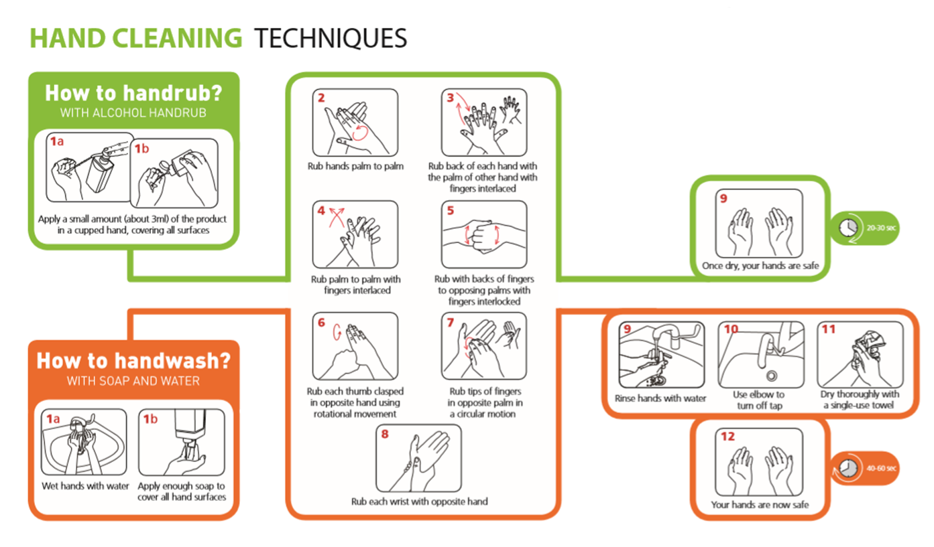**Infection Control**

Personal infection control

* Good hand hygiene – Remember washing hands is more effective than using hand sanitiser – wash hands between tasks
* Cough & Sneezes
  + Cover mouth & nose with a disposable tissue
  + Promptly dispose of the tissue
  + Wash your hands
* Keep our workplace clean & tidy
* Sanitise work surfaces and hand contact surfaces regularly
* Regularly launder your work clothing / uniform and ensure it is clean each day

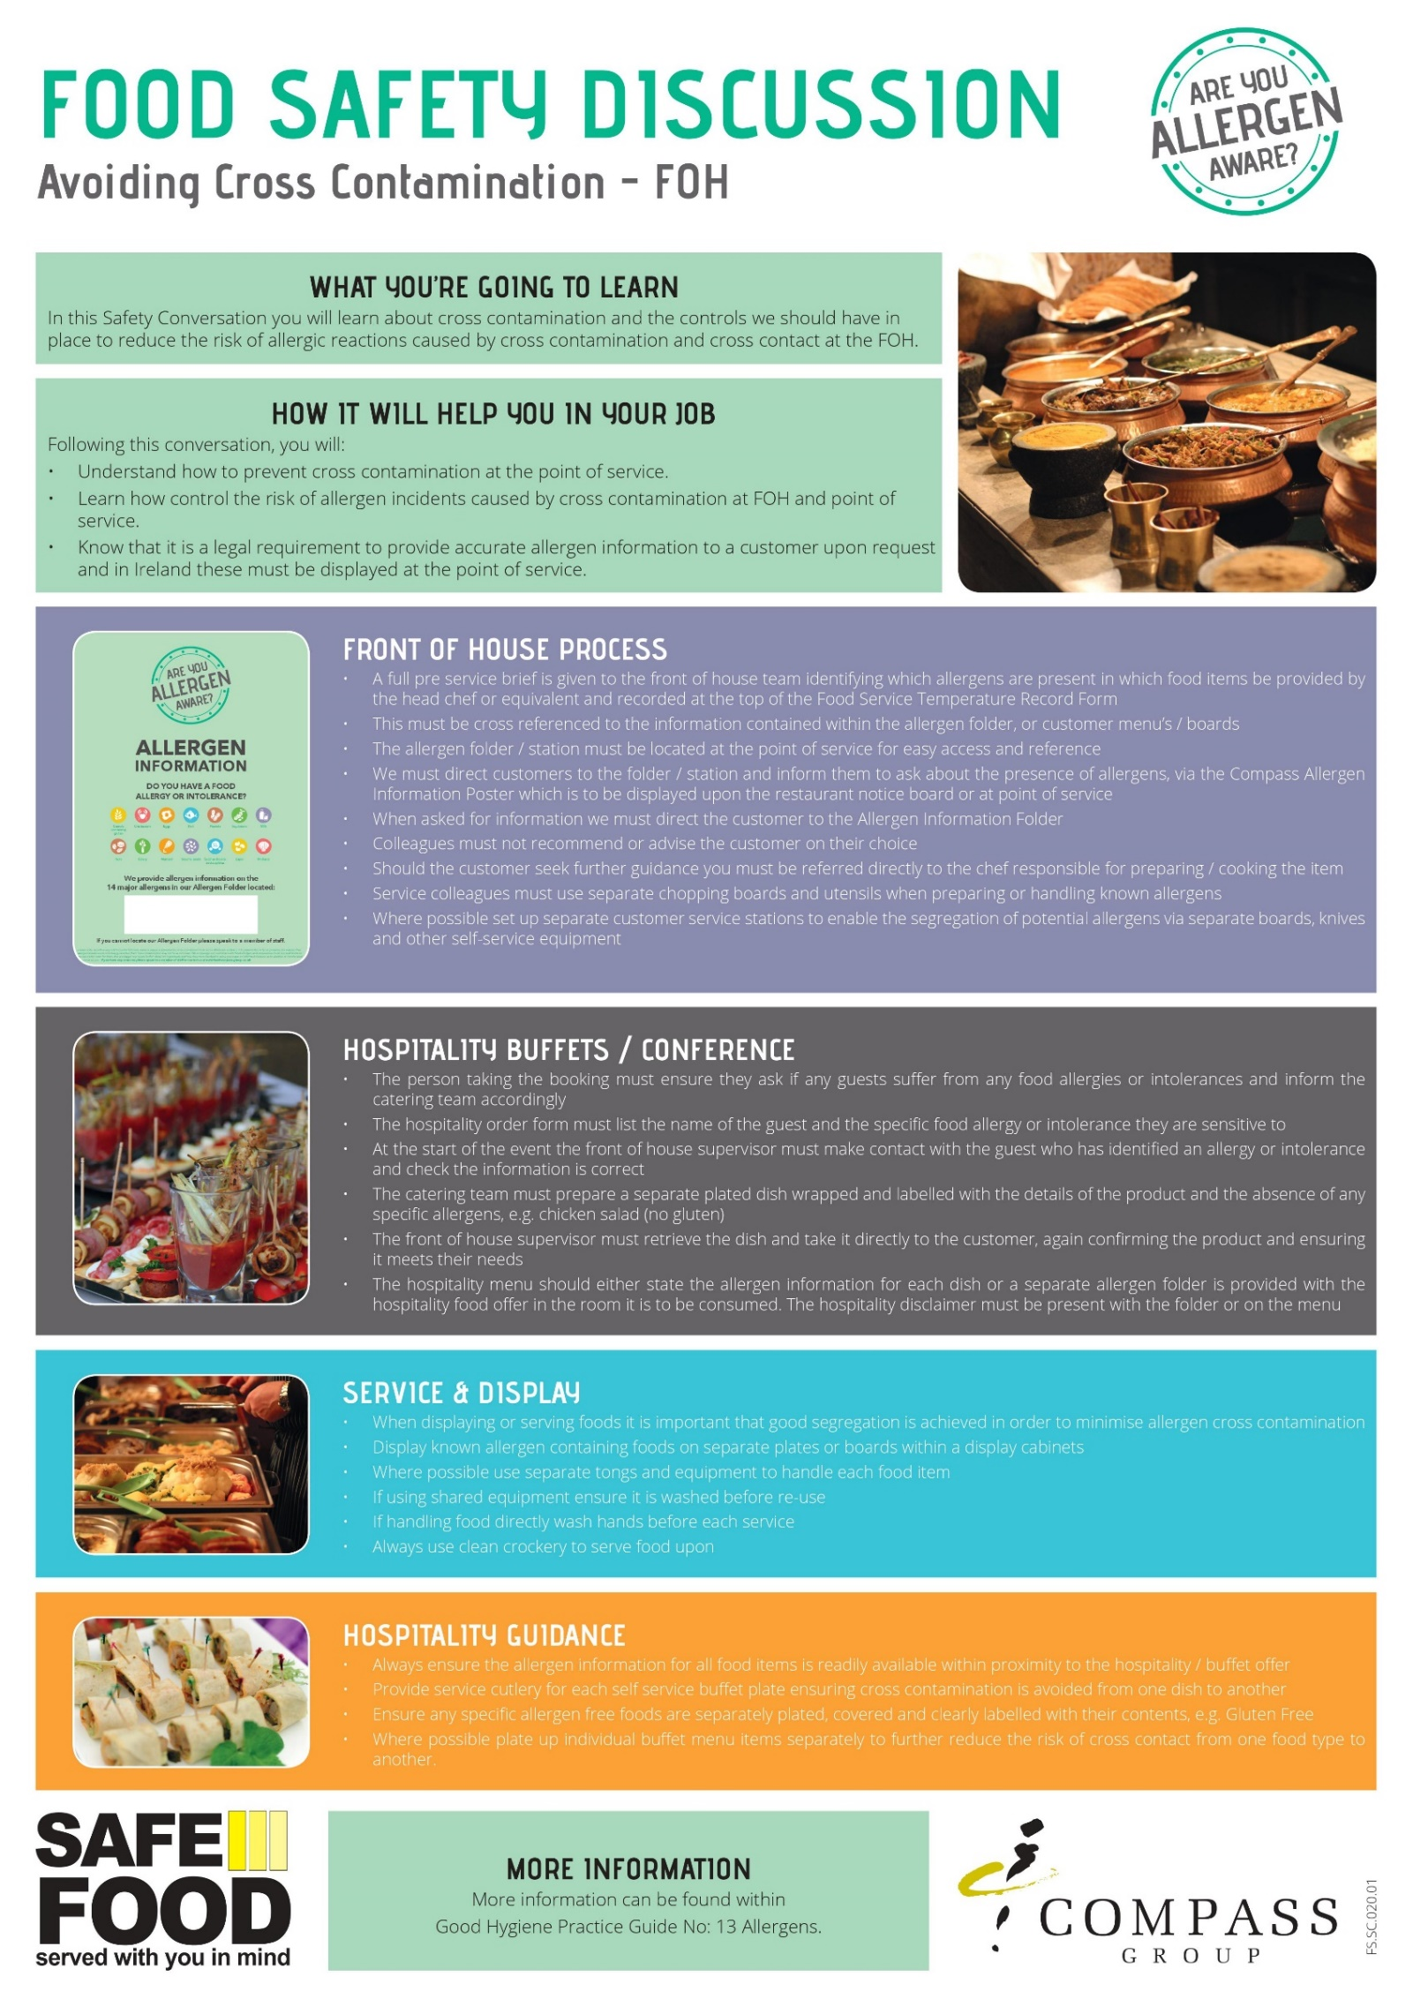

|  |  |
| --- | --- |
|  | THE ESSENTIALS OF FOOD HYGIENE  FOOD HANDLER INDUCTION  SAFETY CONVERSATION |
| **WHAT YOU MUST DO** | |
| Read the essentials of Food Hygiene to understand what is expected of you as a food handler.  You are breaking the law and in breach of company policy if you do not follow these rules.  Please ask your ask manager if you have any questions. | |
| **THE ESSENTIALS OF FOOD HYGIENE** | |
| **Personal Hygiene**   * Keep yourself clean and wear clean clothing. * Tell your supervisor, before commencing work, of any skin, nose, throat, stomach or bowel trouble or infected wound. * Ensure cuts and sores are covered with a waterproof, high visibility dressing such as a blue plaster. * Always eat and drink away from a food room and never cough or sneeze over food. * Follow the sites no smoking policy. * Wash your hands thoroughly before handling ready to eat food, after using the toilet, after handling raw foods, after handling unwashed fruit and vegetables, after handling raw food packaging or waste, before starting work, after every break, after eating and after blowing your nose. * Always consider the potential for cross contamination between raw meat, unwashed fruit and vegetables, their packing and ready-to-eat foods within the catering operation. * Remember it only takes a few bacteria or viruses (germs) to make someone ill. * Avoid unnecessary handling of food and use utensils where possible. | |
| **Safe Food Preparation**   * Follow any food safety instruction provided on food packaging or given by your supervisor. * Check deliveries for damaged packaging and leaked meat juices to ensure ready to eat foods have not become contaminated. Reject the delivery and tell your supervisor if you suspect contamination has occurred. * Prepare food as close to service time as possible. * Keep the handling, preparation, storage of raw meat, unwashed fruit and vegetables and ready to ready to eat food strictly separate. Follow the system at your site. * Use separate complex equipment such as mincers, vac packers and slicers, for raw and ready to eat foods. * Keep perishable food either refrigerated or piping hot. * Always reheat food to ensure it gets piping hot. * Make sure you know what to do if a customer asks you if a product contains something they are allergic to (Check with your manager for your unit procedure). | |
| **Cleaning and Sanitising**   * Always clean as you go and only use the approved sanitisers. * Use the 2-stage cleaning process to clean work surfaces, sinks and equipment after preparing raw foods and unwashed fruit and before preparing ready to eat foods. * Follow the correct cleaning product instructions and where appropriate use the prescribed contact times. * Wash food equipment used in the preparation of raw foods separately from equipment used to prepare ready to eat foods. * Ensure food equipment and clean crockery cannot become contaminated from splashes during cleaning. * Make sure cleaning equipment such as cloths used for raw food preparation areas are not used to clean ready to eat areas. | |

|  |  |  |  |
| --- | --- | --- | --- |
| Safe Systems of Work – Front of House | | | |
| Safety Risk | **Hazard** | **Related Risk Assessments** | **Key Control Measures** |
| Burns and Scalds | Hot Plates  Hot Liquids  Hot Kitchen Equipment | RA-CS  OPS03  ES06 | * Always use waiters’ cloths when handling hot plates * Do not overfill hot beverage jugs, flasks or cups * When filling hot beverage jugs, flasks or cups always give it your full attention do not be distracted by others * Be aware of your surroundings particularly in the kitchen where hot equipment is located |
| Cuts | Broken Glass and Crockery  Sharp Knives | RA-CS  OPS03 | * If you have to polish glasses, take extra care with wine glasses and hold the glass by the top of the stem at the point it connects to the bowl of the glass, do not exert excess pressure and always check glassware for cracks or chips before polishing * If any glassware or crockery shows signs of damage, remove it from service and alert your supervisor * When clearing broken glass and crockery, always use a dust pan and brush, never pick it up with your bare hands * Always dispose of the breakages in a designated broken glass and crockery bin or wrap securely in cardboard before placing in general waste. * If you have to cut fruit on bars, only use a small knife suitable for the task, and keep your fingers clear of the blade at all times |
| Slips, Trips and Falls | Wet Floors  Cables across walk ways  Objects stored in walk ways | RA-CS  OPS03  ES03 | * Always ensure spillages are cleared up immediately * Make use of wet floor signs and verbally warn others around if you spot a spillage * Ensure trailing cables are secured to prevent trip hazards * If you spot something blocking a route, remove it and relocate it to a safer position if you can, alternatively warn others and report to your supervisor |
| Manual Handling | Large items  Repetitive handling  Heavy crockery | ES04  OPS03 | * Ensure that you do not lift or handle anything you do not feel comfortable or capable of doing * Always use trolleys or other aids where available * Always ask for assistance from a colleague * Check the route you are taking before manual handling to ensure it is clear and free of hazards |
| Chemicals | Concentrated chemicals | ES05  OPS03 | * Always wear googles and gloves when handling/ decanting or dispensing concentrated (non-diluted) chemicals * Never spray chemicals in the direction of colleagues or guests * Ensure you read the label on the chemical to understand what it should be used for |
| Electrical Safety  *(Electric Shock and fire)* | Electrical Equipment | RA-CS  OPS03  ES07 | * Always ensure electrical equipment is switched off when not needed * Always switch off equipment before cleaning it * Never touch electrical equipment or sockets with wet hands * Always conduct a visual check of equipment before use, check for;   • No obvious damage to the equipment and no loose or missing screws or other fixings  • No burn marks or staining on the wires or around the plugs and sockets  • No coloured wires are visible where the cable is fixed into the plug  • Cables are not damaged with cuts, abrasions or squashed/ trapped under or between heavy furniture or equipment or have tape covering damage and no bent pins of the plug  • Plug and socket have no signs of damage with cracked or broken casings  • All the wires are stored in such a way that they do not cause a trip hazard or can be pulled from the socket or equipment.   * Where equipment is damaged or defective it must be isolated and removed from use with an “Do not use” sign, until repaired by a competent person |

|  |  |  |  |  |
| --- | --- | --- | --- | --- |
|  | EMPLOYEE RECORD OF SAFETY BRIEFING | | | |
| **Please Note: *This document should be amended to reflect actual practices and procedures at your site*** | | | | |
| **Unit Name:** | | | **Date of Briefing:** | |
| **Event Name:** | | | **Briefing Conducted By:** | |
| By signing below, I confirm that I have been briefed on health and safety information covering Fire & Emergency, Chemical Safety, Allergens, Infection Control, Cleaning and Sanitising Contact Times, Violence at Work, Food Safety and Safe Systems of Work relevant to my role for this venue. I understand it is my responsibility to follow instructions, to work safely and only to do work that I have been trained to do or that I am being trained on or supervised whilst doing. I also understand that I should ask my manager or supervisor at any time if I am unsure of what to do.  I also confirm the following:  that I have not been suffering from any sickness or diarrhoea in the last 48 hours  that I have not had any symptoms of COVID-19 in the last 5 days  that I am not currently experiencing any symptoms of COVID-19  *COVID-19 symptoms include but are not limited to; a new and persistent cough, high temperature, loss of sense of taste or smell.* | | | | |
| **Name** | | **Signature** | | **Date** |
|  | |  | |  |
|  | |  | |  |
|  | |  | |  |
|  | |  | |  |
|  | |  | |  |
|  | |  | |  |
|  | |  | |  |
|  | |  | |  |
|  | |  | |  |
|  | |  | |  |
|  | |  | |  |
|  | |  | |  |
|  | |  | |  |
|  | |  | |  |
|  | |  | |  |
|  | |  | |  |
|  | |  | |  |
|  | |  | |  |
|  | |  | |  |
|  | |  | |  |
|  | |  | |  |
|  | |  | |  |
|  | |  | |  |
|  | |  | |  |
|  | |  | |  |

**RECORD OF OPENING AND CLOSING CHECKS**

**Event Name:** **Area Name:**

|  |  |  |  |  |  |  |  |  |
| --- | --- | --- | --- | --- | --- | --- | --- | --- |
| **OPENING Checklist to be completed at start of shift** | | | |  | **CLOSING Checklist to be completed end of shift** | | | |
| **Opening checks** | **Date** | **Date** | **Date** |  | **Checks** | **Date** | **Date** | **Date** |
|  |  |  |  |  |  |
| Is the area free of any evidence of pests? |  |  |  |  | Is all food stored correctly and within date? |  |  |  |
| Is the area clean and tidy and are all food contact surfaces sanitised? |  |  |  |  | Is the area clean and tidy and are all food contact surfaces sanitised? |  |  |  |
| Do you have a working probe and probe wipes? |  |  |  |  | Is all equipment switched off except for fridges and freezers? |  |  |  |
| Do you have sanitiser spray? ***(Ensure all staff are aware of the contact time: 1 minute)*** |  |  |  |  | Have all maintenance issues been reported to your manager or the maintenance team? |  |  |  |
| Do hand wash basins have hot and cold running water, soap and paper towels? |  |  |  |  | Has all waste been removed to the relevant waste areas? |  |  |  |
| Do hand wash basins have soap and paper towels? |  |  |  |  | Have all chemicals been stored away safely? |  |  |  |
| Do you have the relevant allergen information sheets?  ***(check with lead chef)*** |  |  |  |  | Have all food temperature records been completed for the day? |  |  |  |
| Is all equipment in good working order? |  |  |  |  | **Corrective Actions or Comments to be recorded below:** | | | |
| Are your team in the correct uniform and supplied with relevant PPE as needed? |  |  |  |  |  | | | |
| Are all fire exit routes and doors free from obstructions and are they accessible? |  |  |  |  |
| Have any new staff been fully briefed? |  |  |  |  |

|  |  |
| --- | --- |
| **CHECKED BY:** | **DATE:** |

**Manager to check the record form and sign before filing**

|  |  |  |  |  |  |  |  |
| --- | --- | --- | --- | --- | --- | --- | --- |
| **Event Name:** | | | | | | | **Area Name:** |
| **Fridge Number & Date** | **Temperature oC** | | | | | | **Comments**  ***Log any out-of-range temperature issues and comment as to what action has been taken to rectify, and record any temperature re-checks*** |
| **FRIDGE 1** | **A.M** | **Init.** | **P.M.** | **Init.** | **Night** | **Init** |  |
|  |  |  |  |  |  |  |  |
|  |  |  |  |  |  |  |  |
|  |  |  |  |  |  |  |  |
|  |  |  |  |  |  |  |  |
| **FRIDGE 2** | **A.M** | **Init.** | **P.M.** | **Init.** | **Night** | **Init** |  |
|  |  |  |  |  |  |  |  |
|  |  |  |  |  |  |  |  |
|  |  |  |  |  |  |  |  |
|  |  |  |  |  |  |  |  |
| **FRIDGE 4** | **A.M** | **Init.** | **P.M.** | **Init.** | **Night** | **Init** |  |
|  |  |  |  |  |  |  |  |
|  |  |  |  |  |  |  |  |
|  |  |  |  |  |  |  |  |
|  |  |  |  |  |  |  |  |
| **FRIDGE 5** | **A.M** | **Init.** | **P.M.** | **Init.** | **Night** | **Init** |  |
|  |  |  |  |  |  |  |  |
|  |  |  |  |  |  |  |  |
|  |  |  |  |  |  |  |  |
|  |  |  |  |  |  |  |  |
| **FREEZER 1** | **A.M** | **Init.** | **FREEZER 2** | | **A.M** | **Init** |  |
|  |  |  |  | |  |  |  |
|  |  |  |  | |  |  |  |
|  |  |  |  | |  |  |  |
|  |  |  |  | |  |  |  |

**RECORD OF FRIDGE AND FREEZER TEMPERATURE CHECKS**

**Temp Range: Storage: +1oC to +5o C. Critical Limit +8 o C Service and display Storage: +1oC to +8o C Twice per day (3 if night shift operation)**

**Freezers: -18oC to –23oC Critical Limit -15 o C Once per day Insert temperature and initial clearly.**

|  |  |
| --- | --- |
| **CHECKED BY:** | **DATE:** |

**Manager to check the record form and sign. Retain for 6 months**

**RECORD OF FOOD TEMPERATURE CHECKS**

|  |  |  |  |  |  |  |  |  |  |  |  |  |  |
| --- | --- | --- | --- | --- | --- | --- | --- | --- | --- | --- | --- | --- | --- |
| **Event Name:** | | | | | | | **Area Name:** | | | | | | |
| **FOOD ITEM** | **COOKING/REHEATING**  **TEMPERATURE**  Min +75°C | | | **HOT HOLD/ DISPLAY / SERVICE**  Min +63°C  **1st Temp – 90 mins after cooking/reheating** | | | **HOT HOLD/ DISPLAY / SERVICE**  Min +63°C  **2nd Temp –90 mins later** | | | **HOT HOLD/ DISPLAY / SERVICE**  Min +63°C  **3rd Temp – 90 mins later** | | | **COMMENTS** |
| Time | Temp | Init | Time | Temp | Init | Time | Temp | Init | Time | Temp | Init | ***Record any action taken to rectify out-of-range temperatures*** |
|  |  |  |  |  |  |  |  |  |  |  |  |  |  |
|  |  |  |  |  |  |  |  |  |  |  |  |  |  |
|  |  |  |  |  |  |  |  |  |  |  |  |  |  |
|  |  |  |  |  |  |  |  |  |  |  |  |  |  |
|  |  |  |  |  |  |  |  |  |  |  |  |  |  |
|  |  |  |  |  |  |  |  |  |  |  |  |  |  |
|  |  |  |  |  |  |  |  |  |  |  |  |  |  |
|  |  |  |  |  |  |  |  |  |  |  |  |  |  |
|  |  |  |  |  |  |  |  |  |  |  |  |  |  |
|  |  |  |  |  |  |  |  |  |  |  |  |  |  |
|  |  |  |  |  |  |  |  |  |  |  |  |  |  |
|  |  |  |  |  |  |  |  |  |  |  |  |  |  |
|  |  |  |  |  |  |  |  |  |  |  |  |  |  |
|  |  |  |  |  |  |  |  |  |  |  |  |  |  |
|  |  |  |  |  |  |  |  |  |  |  |  |  |  |

**Hot Holding temperature to be taken every 90 minutes from final cook time.**

**Hot Holding temperature to be taken every 90 minutes from final cook time.**

**Sign off after each process completed in the Initial column.**

|  |  |
| --- | --- |
| **CHECKED BY:** | **DATE:** |

**Manager to check the record form and sign before filing record. Retain for 6 months**

|  |  |  |  |  |  |  |
| --- | --- | --- | --- | --- | --- | --- |
| **FOOD WASTAGE RECORD SHEET** | | | | | | |
| **Event Name:**  **Event Date:** | | | | | | | |
| Date: | Kitchen/ Location | Description of Food Wasted | Quantity | Value | Reason | Signature | | |
|  |  |  |  |  |  |  | | |
|  |  |  |  |  |  |  | | |
|
|  |  |  |  |  |  |  | | |
|
|  |  |  |  |  |  |  | | |
|
|  |  |  |  |  |  |  | | |
|
|  |  |  |  |  |  |  | | |
|
|  |  |  |  |  |  |  | | |
|
|  |  |  |  |  |  |  | | |
|
|  |  |  |  |  |  |  | | |
|  |  |  |  |  |  |  | | |
|  |  |  |  |  |  |  | | |

|  |  |  |  |  |  |  |  |  |  |  |
| --- | --- | --- | --- | --- | --- | --- | --- | --- | --- | --- |
| **SHORTAGES LIST AND REPAIRS LOG** | | | | | | | | | | |
| **Event Name:** | | | | | | **Catering Area:** | | | | |
| **SHORTAGES** | | | | | | | | | | |
| **Date** | **Items** | **Date** | | **Items** | | | | **Date** | **Items** | |
|  |  |  | |  | | | |  |  | |
|  |  |  | |  | | | |  |  | |
|  |  |  | |  | | | |  |  | |
|  |  |  | |  | | | |  |  | |
|  |  |  | |  | | | |  |  | |
|  |  |  | |  | | | |  |  | |
|  |  |  | |  | | | |  |  | |
|  |  |  | |  | | | |  |  | |
|  |  |  | |  | | | |  |  | |
|  |  |  | |  | | | |  |  | |
| **REPAIRS LOG** | | | | | | | | | | |
| **Date** | **Nature of Fault / Problem** | | **Reported By** | | **Reported to** | | **Date of Follow Up Call** | **Action taken** | | **Date Completed** |
|  |  | |  | |  | |  |  | |  |
|  |  | |  | |  | |  |  | |  |
|  |  | |  | |  | |  |  | |  |
|  |  | |  | |  | |  |  | |  |

|  |  |
| --- | --- |
| **EVENT DE-BRIEF RECORD** | |
| **Event Name:** | |
| **Catering Area:** | **Supervisor/Manager:** |
| Area | Comments |
| Equipment: is it sufficient and working? List any issues or problems. |  |
| Retail outlet layout and design: is it satisfactory/unsatisfactory? List any improvement suggestions. |  |
| Storage: is there sufficient refrigeration and dry goods storage? |  |
| Menu: is it appropriate for outlet size and equipment? |  |
| Front of House Staff: provide any general comments. |  |
| Any other comments: for example, safety or welfare issues. |  |
| Signature: | Date: |

**Please return this completed form to the Event Manager**