COMPASS GROUP UK & IRELAND
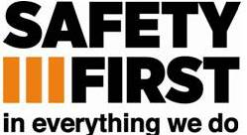

PORTERING RISK ASSESSMENTS – EMPLOYEE TRAINING RECORD
EMPLOYEE’S NAME: |  |  |  | JOB TITLE:
Ref | INSTRUCTION GIVEN  Hazards, Risks & Safe System of Work | Tick if risk assessment applicable to this employee’s job | Date |  | Trainer’s Signature | Employee’s Signature
POR 01 | Barrier & Isolation Cleaning
POR 02 | Clinical & Special Waste
POR 03 | Liquid Nitrogen
POR 04 | Medical Gases
POR 05 | Mortuary Duties
POR 06 | Portering of Hospital Patients
POR 07 | Radiation
POR 08 | Transport of Pathological Specimens & Blood

