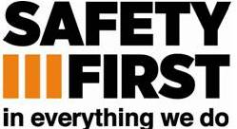 COMPASS GROUP UK & IRELAND

BUSINESS & OFFICE RISK ASSESSMENTS – EMPLOYEE TRAINING RECORD
EMPLOYEE’S NAME: |  |  | JOB TITLE:
Ref | INSTRUCTION GIVEN  Hazards, Risks & Safe System of Work | Tick if risk assessment applicable to this employee’s job | Date | Trainer’s Signature | Employee’s Signature
OFF 01 | Reception & Switchboard Duties
OFF 02 | Security Duties
OFF 03 | Working in Post Rooms
OFF 04 | Guillotines
OFF 05 | Laminators
OFF 06 | Paper Shredders
OFF 07 | Photocopying Machines & Printers

