COMPASS GROUP UK & IRELAND – RISK ASSESSMENT REF. MAN 03 DSE WORKSTATION ASSESSMENT

Site/Unit Name: Bank of England | Unit No: 2987652
Assessed by: Bruce Mason | Date of Assessment:  21/04/2016

Sections 1 to 6 of this DSE Workstation Assessment should be completed for all workstations, whether or not they are used by defined DSE Users. Section 7 must be completed by each DSE user to identify whether they are a ‘Defined DSE User’. All Defined DSE Users must complete Section 8.

Where workstations are used infrequently by employees who are not Defined DSE Users, the standards required of the workstation will be less than one that is.

Consider each of the risk factors and answer each question either Yes, No or Not applicable. Where a No answer is given, consider the possible management actions suggested and record what action is taken in the Action/Comments column.

Line Managers must review the assessment every 3 years or sooner if there are significant changes to the workplace, workstation or in working arrangements and following a relevant workstation-related incident or ill health related to the use of DSE.

CONTENTS
Section Number | DSE Workstation Risk Assessment Section | Page Number
1 | Display screens | 2
2 | Keyboards | 3
3 | Mouse, Trackball etc | 4
4 | Software | 4
5 | Furniture | 5 & 6
6 | Environment | 6
7 | DSE User Questionnaire | 7
8 | The User | 8

Risk Factors | Y/N or  NA | Possible Management Action if  “No” | Actions/  Comments
1. Display Screens |  | Make sure the screen is clean & that cleaning materials are available  Check that text and background colours work well together.  Software settings may need adjusting to alter text size  Adjust text & background colours. If problems persist, arrange for repair  Intensive graphic work or fine attention to detail may require a larger screen size  Separate adjustment controls are not essential if the user can read the screen at all times  Swivel & tilt mechanisms may not be fitted but can be added. The screen may need replacing if the mechanism is absent/unsatisfactory, work is intensive or the user has problems getting a comfortable position  The screen or desk may need to be moved and/or the screen may need shielding. Screens that use dark characters on a light background are less prone to glare & reflections  Check that blinds work. Vertical blinds can be better than horizontal ones  If this does not work, consider anti- glare screen filters as a last resort
Are the characters clear and readable? | Y

Is the text size comfortable to read? | Y
Is the image stable i.e. clear of flicker? | Y
Is the screen’s specification suitable for its intended use?  Are the brightness and/or contrast adjustable? | Y  Y |  | Adjust using the controls on the front of the monitor.
Does the screen swivel & tilt? | Y
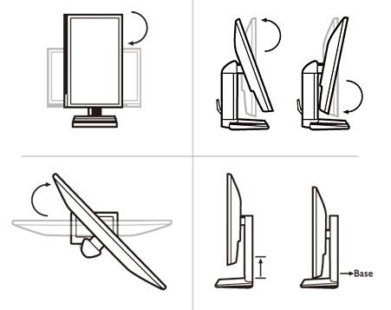
Is the screen free from glare and reflections? | Y
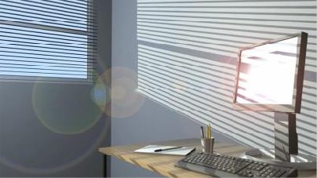
Are adjustable window coverings provided and in good condition? | Y

Thank you for using www.freepdfconvert.com service!

Only two pages are converted. Please Sign Up to convert all pages. https://www.freepdfconvert.com/membership

