COMPASS GROUP UK & IRELAND

Ref. MAN 09 GENERAL MANUAL HANDLING RISK ASSESSMENT
Site / Unit Name | High Street Bank Ltd | Unit No | 01234
Location being assessed | Kitchen and Dining Areas | Date | 10/11/14
Site / Unit Manager | Diane Smith

- List below the manual handling tasks associated with the work activity.  - Using the diagram below and your judgement consider if the task involves low or high risk manual handling activities. Where the loads handled are heavier than the weights shown in the zones for women and men in the diagram, the task should be marked High risk.  - Special consideration must be given to the personal physical capabilities of children and young persons  - Where you consider a task to involve High Risks*, use the detailed Task Specific Manual Handling Risk Assessment to identify significant risks and control measures.  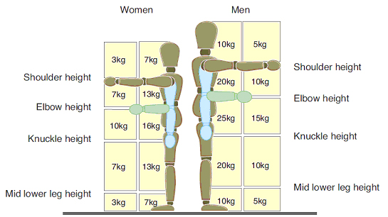 | Overall Level of Manual Handling Risk (✓)
MANUAL HANDLING TASKS | Low | High*
- Receiving goods deliveries |  | 
- Providing hospitality food and beverages to 1st Floor offices via lift | 
- Providing hospitality to 1st Floor offices when lift is not working |  | 
- Filling canned drinks vending machines |  | 
- Filling food and hot drinks vending machines | 
- Setting up food service counter units | 
- Moving tables and chairs in dining room |  | 
- Food preparation, cooking and service | 
- Moving loaded self-clearing trolleys from dining room to dishwasher room | 

Site / Unit Manager | D Smith | Signature

* Guidance on manual handling risks is provided in the A to Z of Health and Safety section of the HSE website

