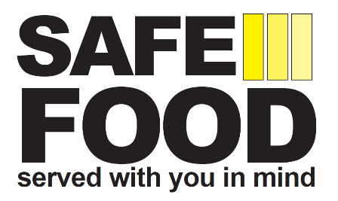

Unit: Unit No:
Complete Probe Thermometer check monthly.
Refer to the Good Hygiene Practice Guide No.9 (Cooking) for detailed instructions on how to carry out your probe thermometer accuracy checks.

- Use one form per probe thermometer.
- Units should have as a minimum 3 probe thermometers – 1 for ready-to-eat food, 1 for raw food and 1 spare.
- Retain record for 12 months.
- Manager to check, sign and date the record before filing.

Make / Model | Serial / Identification No. | Location Use | Intended use (Ready-to eat, raw food)

Date | Month | Year | Reading  +/- 0.5ºC |  | Corrective Action Required |  | Corrective Action Taken | Signed
Date | Month | Year | 0ºC | +100ºC | Yes | No | Corrective Action Taken | Signed
 | January
 | February
 | March
 | April
 | May
 | June
 | July
 | August
 | September
 | October
 | November
 | December
UNIT MANAGER: |  |  |  |  |  |  | DATE:

