Retail Event

Health and Safety Pack

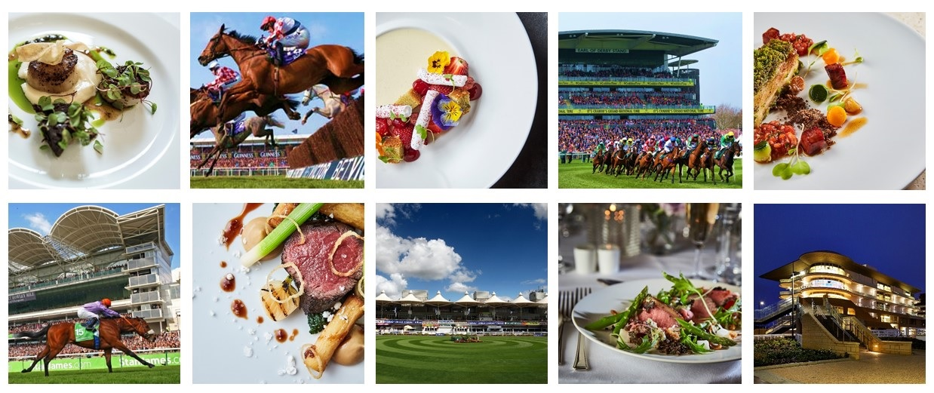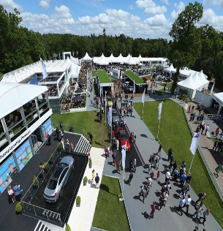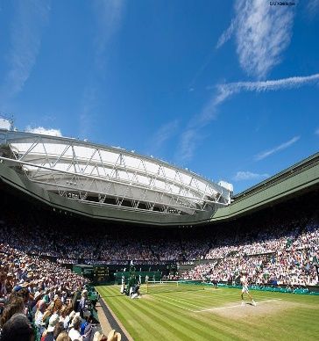

Unit Name:

Event Name:

Event Date:

Retail Area:

**THIS PAGE IS LEFT INTENTIONALLY BLANK**

**Retail Event Pack Contents and Instructions for Use**

|  |  |  |
| --- | --- | --- |
| **Document** | ***Instructions*** | **Page** |
| **Essentials of Hygiene and Rules of Safety** | *Information only* | **4** |
| **Catering Cleaning Schedule** | *Provides guidance on cleaning within the unit* | **5** |
| **Opening and Closing Checklist** | ***Opening Checklist*** *to be complete at the start of each day.* ***Closing Checklist*** *to be completed at the end of each day* | **6** |
| **Fridge Temperature Record** | *Record temperatures twice daily and keep the record within this pack* | **7** |
| **Food Service Temperature Record** | *Use to record temperature of hot food.* ***MUST*** *be documented at time of monitoring* | **8** |
| **Wastage Record Sheet** | *Complete at the end of the day, recording any wastage* | **9** |

**Please return this completed pack to your manager.**

|  |  |
| --- | --- |
|  | THE ESSENTIALS OF FOOD HYGIENE  FOOD HANDLER INDUCTION  SAFETY CONVERSATION |
| **WHAT YOU MUST DO** | |
| Read the essentials of Food Hygiene to understand what is expected of you as a food handler.  You are breaking the law and in breach of company policy if you do not follow these rules.  Please ask your ask manager if you have any questions. | |
| **THE ESSENTIALS OF FOOD HYGIENE** | |
| **Personal Hygiene**   * Keep yourself clean and wear clean clothing. * Tell your supervisor, before commencing work, of any skin, nose, throat, stomach or bowel trouble or infected wound. * Ensure cuts and sores are covered with a waterproof, high visibility dressing such as a blue plaster. * Always eat and drink away from a food room and never cough or sneeze over food. * Follow the sites no smoking policy. * Wash your hands thoroughly before handling ready to eat food, after using the toilet, after handling raw foods, after handling unwashed fruit and vegetables, after handling raw food packaging or waste, before starting work, after every break, after eating and after blowing your nose. * Always consider the potential for cross contamination between raw meat, unwashed fruit and vegetables, their packing and ready-to-eat foods within the catering operation. * Remember it only takes a few bacteria or viruses (germs) to make someone ill. * Avoid unnecessary handling of food and use utensils where possible. | |
| **Safe Food Preparation**   * Follow any food safety instruction provided on food packaging or given by your supervisor. * Check deliveries for damaged packaging and leaked meat juices to ensure ready to eat foods have not become contaminated. Reject the delivery and tell your supervisor if you suspect contamination has occurred. * Prepare food as close to service time as possible. * Keep the handling, preparation, storage of raw meat, unwashed fruit and vegetables and ready to ready to eat food strictly separate. Follow the system at your site. * Use separate complex equipment such as mincers, vac packers and slicers, for raw and ready to eat foods. * Keep perishable food either refrigerated or piping hot. * Always reheat food to ensure it gets piping hot. * Make sure you know what to do if a customer asks you if a product contains something they are allergic to (Check with your manager for your unit procedure). | |
| **Cleaning and Sanitising**   * Always clean as you go and only use the approved sanitisers. * Use the 2-stage cleaning process to clean work surfaces, sinks and equipment after preparing raw foods and unwashed fruit and before preparing ready to eat foods. * Follow the correct cleaning product instructions and where appropriate use the prescribed contact times. * Wash food equipment used in the preparation of raw foods separately from equipment used to prepare ready to eat foods. * Ensure food equipment and clean crockery cannot become contaminated from splashes during cleaning. * Make sure cleaning equipment such as cloths used for raw food preparation areas are not used to clean ready to eat areas. | |

|  |  |  |  |  |
| --- | --- | --- | --- | --- |
| **CLEANING SCHEDULE** | | | | |
| **ITEM** | **PRODUCT** | **PPE REQUIRED** | **DOSE RATE** | **METHOD \*** |
| **Floors** | ***Multi EL10*** | Nitrile/Latex-free Gloves EN374* | 2 x 20ml pumps per 5l of warm water | Sweep up debris. Apply hot solution using clean mop or long handle scrubber, paying attention to floor/wall joint, around equipment, under and behind equipment. Rinse and mop over with fresh clean water. Allow to air dry. |
| **Work Surfaces** | ***Oasis Pro20 or Aseptopol*** | Nitrile/Latex-free Gloves EN374* | 20ml via dispenser per 600ml trigger spray | Remove debris. Apply sanitiser solution with a cloth or hand sprayer. Ensure that attention is given to legs and under edges. Wipe and then re-apply sanitiser and allow a 5-minute contact time. Wipe and Rinse and allow to air dry or dry with paper towels. |
| **Refrigerators / Freezers** | ***Oasis Pro20 or Aseptopol*** | Nitrile/Latex-free Gloves EN374* | 20ml via dispenser per 600ml trigger spray | Check and organise fridges daily. Check for spillages and wipe up [spillages should be wiped up immediately]. |
| **Hot Food Display Equipment** | ***Oasis Pro20 or Aseptopol*** | Nitrile/Latex-free Gloves EN374 | 20ml via dispenser per 600ml trigger spray | After use - switch off power supply and allow to cool. Remove containers and transfer to pan wash. Wash down all surfaces and rinse. Remove deposits from door runners with a stiff brush. Brush floor under appliance and clean up spillages. |
| **Temperature Probes** | ***Oasis Pro20, Aseptopol or Probe Wipes*** | Nitrile/Latex-free Gloves EN374* | 20ml via dispenser per 600ml trigger spray | Remove debris. Apply solution with a cloth or hand sprayer. Ensure that attention is given to the entire length of the probe needle, reapply solution and allow a 1-minute contact time. Rinse and allow to air dry or dry with paper towels. |
| **Sinks and Wash Hand Basins** | ***Oasis Pro 20 or Aseptopol*** | Nitrile/Latex-free Gloves EN374* | 20ml via dispenser per 600ml trigger spray | Clean with the general-purpose detergent. Remove any tide marks from the bowl and drainer with a scouring pad or cloth. Include taps, waste outlets and splash-backs in cleaning record. Rinse thoroughly with cold water. Apply sanitiser to all surfaces and leave to air dry. Ensure sufficient supply of towels and soap are maintained at the wash hand basin. |
| **Equipment Racks and Shelving** | ***Oasis Pro20 or Aseptopol*** | Nitrile/Latex-free Gloves EN374* | 20ml via dispenser per 600ml trigger spray | Remove stock and utensils/equipment from shelves and racking. Sweep debris off surfaces and sweep floor under. Clean with solution, rinse and allow to air dry. Replace stock and utensils/equipment. Ensure equipment is placed inverted as far as practicable. |
| **Waste Bins** | ***Multi EL10*** | Nitrile/Latex-free Gloves EN374* | 2 x 20ml pumps per 5l of warm water | Empty bins frequently throughout the day. Do not allow contents to overflow. Wash out empty bin or bin liner holder with solution. Clean external casing and the lid, paying attention to underside of lid and the handle [if fitted]. Rinse and allow to air dry. |

**SAFETY PRECAUTIONS**

* **Before cleaning electrical machinery ensure it is switched off and isolated from the mains.**
* **Before cleaning gas appliances ensure they are turned off. Take care when cleaning hot items.**
* **Follow all safety precautions shown in COSHH Product Task Cards for the cleaning product being used and always wear the correct PPE especially when handling or dispensing concentrated chemicals**

**RECORD OF OPENING AND CLOSING CHECKS**

**Event Name:** **Area Name:**

|  |  |  |  |  |  |  |  |  |
| --- | --- | --- | --- | --- | --- | --- | --- | --- |
| **OPENING Checklist to be completed at start of shift** | | | |  | **CLOSING Checklist to be completed end of shift** | | | |
| **Opening checks** | **Date** | **Date** | **Date** |  | **Checks** | **Date** | **Date** | **Date** |
|  |  |  |  |  |  |
| Is the area free of any evidence of pests? |  |  |  |  | Is all food stored correctly and within date? |  |  |  |
| Is the area clean and tidy and are all food contact surfaces sanitised? |  |  |  |  | Is the area clean and tidy and are all food contact surfaces sanitised? |  |  |  |
| Do you have a working probe and probe wipes? |  |  |  |  | Is all equipment switched off except for fridges and freezers? |  |  |  |
| Do you have sanitiser spray? ***(Ensure all staff are aware of the contact time: 1 minute)*** |  |  |  |  | Have all maintenance issues been reported to your manager or the maintenance team? |  |  |  |
| Do hand wash basins have hot and cold running water, soap and paper towels? |  |  |  |  | Has all waste been removed to the relevant waste areas? |  |  |  |
| Do hand wash basins have soap and paper towels? |  |  |  |  | Have all chemicals been stored away safely? |  |  |  |
| Do you have the relevant allergen information sheets?  ***(check with lead chef)*** |  |  |  |  | Have all food temperature records been completed for the day? |  |  |  |
| Is all equipment in good working order? |  |  |  |  | **Corrective Actions or Comments to be recorded below:** | | | |
| Are your team in the correct uniform and supplied with relevant PPE as needed? |  |  |  |  |  | | | |
| Are all fire exit routes and doors free from obstructions and are they accessible? |  |  |  |  |
| Have any new staff been fully briefed? |  |  |  |  |

|  |  |
| --- | --- |
| **CHECKED BY:** | **DATE:** |

**Manager to check the record form and sign before filing**

|  |  |  |  |  |  |  |  |
| --- | --- | --- | --- | --- | --- | --- | --- |
| **Event Name:** | | | | | | | **Area Name:** |
| **Fridge Number & Date** | **Temperature oC** | | | | | | **Comments**  ***Log any out-of-range temperature issues and comment as to what action has been taken to rectify, and record any temperature re-checks*** |
| **FRIDGE 1** | **A.M** | **Init.** | **P.M.** | **Init.** | **Night** | **Init** |  |
|  |  |  |  |  |  |  |  |
|  |  |  |  |  |  |  |  |
|  |  |  |  |  |  |  |  |
|  |  |  |  |  |  |  |  |
| **FRIDGE 2** | **A.M** | **Init.** | **P.M.** | **Init.** | **Night** | **Init** |  |
|  |  |  |  |  |  |  |  |
|  |  |  |  |  |  |  |  |
|  |  |  |  |  |  |  |  |
|  |  |  |  |  |  |  |  |
| **FRIDGE 4** | **A.M** | **Init.** | **P.M.** | **Init.** | **Night** | **Init** |  |
|  |  |  |  |  |  |  |  |
|  |  |  |  |  |  |  |  |
|  |  |  |  |  |  |  |  |
|  |  |  |  |  |  |  |  |
| **FRIDGE 5** | **A.M** | **Init.** | **P.M.** | **Init.** | **Night** | **Init** |  |
|  |  |  |  |  |  |  |  |
|  |  |  |  |  |  |  |  |
|  |  |  |  |  |  |  |  |
|  |  |  |  |  |  |  |  |
| **FREEZER 1** | **A.M** | **Init.** | **FREEZER 2** | | **A.M** | **Init** |  |
|  |  |  |  | |  |  |  |
|  |  |  |  | |  |  |  |
|  |  |  |  | |  |  |  |
|  |  |  |  | |  |  |  |

**RECORD OF FRIDGE AND FREEZER TEMPERATURE CHECKS**

**Temp Range: Storage: +1oC to +5o C. Critical Limit +8 o C Service and display Storage: +1oC to +8o C Twice per day (3 if night shift operation)**

**Freezers: -18oC to –23oC Critical Limit -15 o C Once per day Insert temperature and initial clearly.**

|  |  |
| --- | --- |
| **CHECKED BY:** | **DATE:** |

**Manager to check the record form and sign. Retain for 6 months**

**RECORD OF FOOD TEMPERATURE CHECKS**

|  |  |  |  |  |  |  |  |  |  |  |  |  |  |
| --- | --- | --- | --- | --- | --- | --- | --- | --- | --- | --- | --- | --- | --- |
| **Event Name:** | | | | | | | **Area Name:** | | | | | | |
| **FOOD ITEM** | **COOKING/REHEATING**  **TEMPERATURE**  Min +75°C | | | **HOT HOLD/ DISPLAY / SERVICE**  Min +63°C  **1st Temp – 90 mins after cooking/reheating** | | | **HOT HOLD/ DISPLAY / SERVICE**  Min +63°C  **2nd Temp –90 mins later** | | | **HOT HOLD/ DISPLAY / SERVICE**  Min +63°C  **3rd Temp – 90 mins later** | | | **COMMENTS** |
| Time | Temp | Init | Time | Temp | Init | Time | Temp | Init | Time | Temp | Init | ***Record any action taken to rectify out-of-range temperatures*** |
|  |  |  |  |  |  |  |  |  |  |  |  |  |  |
|  |  |  |  |  |  |  |  |  |  |  |  |  |  |
|  |  |  |  |  |  |  |  |  |  |  |  |  |  |
|  |  |  |  |  |  |  |  |  |  |  |  |  |  |
|  |  |  |  |  |  |  |  |  |  |  |  |  |  |
|  |  |  |  |  |  |  |  |  |  |  |  |  |  |
|  |  |  |  |  |  |  |  |  |  |  |  |  |  |
|  |  |  |  |  |  |  |  |  |  |  |  |  |  |
|  |  |  |  |  |  |  |  |  |  |  |  |  |  |
|  |  |  |  |  |  |  |  |  |  |  |  |  |  |
|  |  |  |  |  |  |  |  |  |  |  |  |  |  |
|  |  |  |  |  |  |  |  |  |  |  |  |  |  |
|  |  |  |  |  |  |  |  |  |  |  |  |  |  |
|  |  |  |  |  |  |  |  |  |  |  |  |  |  |
|  |  |  |  |  |  |  |  |  |  |  |  |  |  |

**Hot Holding temperature to be taken every 90 minutes from final cook time.**

**Hot Holding temperature to be taken every 90 minutes from final cook time.**

**Sign off after each process completed in the Initial column.**

|  |  |
| --- | --- |
| **CHECKED BY:** | **DATE:** |

**Manager to check the record form and sign before filing record. Retain for 6 months**

|  |  |  |  |  |  |  |
| --- | --- | --- | --- | --- | --- | --- |
| **FOOD WASTAGE RECORD SHEET** | | | | | | |
| **Event Name:** 1111 **Event Date:** 2222 | | | | | | | |
| Date: | Kitchen/ Location | Description of Food Wasted | Quantity | Value | Reason | Signature | | |
|  |  |  |  |  |  |  | | |
|  |  |  |  |  |  |  | | |
|
|  |  |  |  |  |  |  | | |
|
|  |  |  |  |  |  |  | | |
|
|  |  |  |  |  |  |  | | |
|
|  |  |  |  |  |  |  | | |
|
|  |  |  |  |  |  |  | | |
|
|  |  |  |  |  |  |  | | |
|
|  |  |  |  |  |  |  | | |
|  |  |  |  |  |  |  | | |
|  |  |  |  |  |  |  | | |

**Please return this completed form to the Event Manager**