9.0 People Management

The Line Manager is responsible for the people management of those individuals who report to them. Employees should be managed in line with the Compass standard policies and procedures which are provided to ensure consistency across the company. By following standard policies and procedures, we can be confident that statutory requirements are being met and that both the company and its employees are properly protected.
All People Management processes and procedures are held within the People Works Self Service Portal, accessible via Compass Connect.
It is the Line Managers responsibility to familiarise themselves with the company's standard policies and procedures, there are also various 'Manager's Guides' available to guide Managers on the Compass standard policies and procedures.
Compass Standard Policies and Procedures:
Disciplinary Performance Review
Probationary Redundancy
Grievance/Absence
Maternity Paternity Adoption
Flexible Working
Agency Workers
Client Removal
Death in Service
TUPE Loss
TUPE Gain
The Unit Manager will utilise the Training Management System (TMS) for all bookings of Industry Training, Medicals, Survival Training, Emergency Response duty training e.g. First Aid/Advanced First Aid. & Helicopter Duties. The TMS User Guide should be utilised for all bookings.
Note: this list is not exhaustive.

Peopleworks consists of the following:



There is a section specifically for Offshore, providing support in these areas:
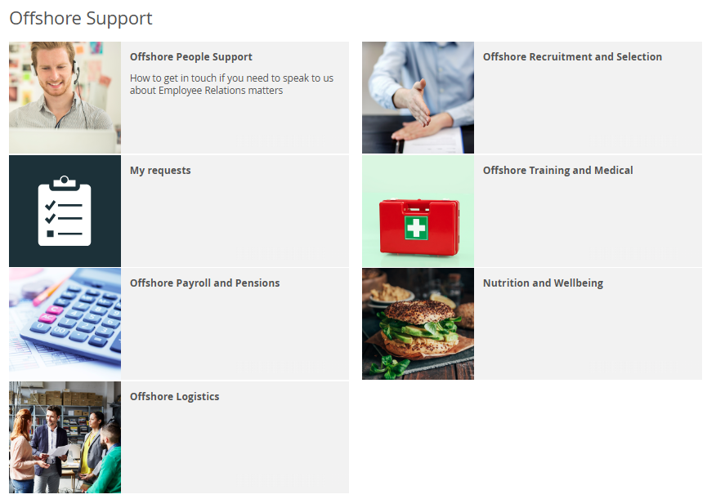

9.1 Uniform Standards

The Unit Manager shall ensure that all crew are always dressed correctly, that uniforms are clean and smart with shoes kept clean and general appearance is to an acceptable standard.
Crew shall be issued with the appropriate items of uniform. Uniforms shall be ordered and replaced as necessary by placing orders direct to supplier.
SAFETY SHOES
It is the Unit Managers responsibility to order replacement pairs of safety shoes for their crew. Shoes should only be replaced when unfit for use through normal wear and tear.
When you require safety shoes, populate the order form contained within the forms folder, using the drop-down boxes highlighted in blue for code, style, and size
ESS have a range of styles of Safety Shoe/Boot from 2 manufacturers, Anvil & Wearertech. There are two Safety Shoe Order Forms, dependent on the manufacturer.
The 'Safety Shoes Order Form' should be emailed to foodbuy.lockhart@bunzl.co.uk
If the shoes need to be delivered to ESS Head Office, please clearly identify this in your e mail
Upon receipt of the shoes the Unit Manager should sign and retain the delivery note and enter the costs on the Uniform Annual Budget sheet.
Any non-conformances or credit requests should be raised using the Non Conformance Report and Credit Request sheet and emailed to compass.callcentre@bunzl.co.uk and copied to hseq.aberdeen@compass-group.co.uk
If you are required to return the shoes you should advise Strachans that they will be included in the next container. The shoes should be in their original packaging.
This procedure shall be followed if an employee maintains they cannot wear the issued safety shoes due to problems with their feet:
- Employee to obtain certificate from doctor, outlining the problem.
- Manager to speak to uniform supplier to arrange suitable, alternative type of shoe.
- Employee to visit supplier's premises to try on shoe for suitability. If shoes are suitable, the Manager shall order through normal ordering procedure. If shoes are not suitable, employee may make a recommendation for consideration.
- Manager shall speak to their Operations Manager/ Support Manager to obtain price restrictions and shoe specifications.
NOTE: This procedure shall only be used when an employee obtains medical certification. Shoes shall always be black in colour. Under no circumstances shall employees obtain and pay for their own safety equipment.

9.2 Labour Deployment

The Unit Manager shall ensure that current manning schedule is applied as per the contract scope. This manning schedule will be issued by the Operations Manager/Support Manager as part of mobilisation.
Crew levels should be maintained within the POB banding level, any changes to the required level of crew should be agreed with your Operations Manager/Support Manager.
Labour Deployment:
- Manning Schedule.
This overview sheet will be held on file in the Unit Manager's office.
This manning schedule gives supervisory staff information at a glance as to the required crew to POB ratio.
- Task Analysis Sheet.
This is a sheet that is specific to an individual which will give him/her details of what needs to be done throughout the day. This will be on display at the individual's work site.
Layout
It is headed with the job title. Down the left-hand side, the day will be split up into manage- able sections with no section being more than 2½ hours.
Then against each section there should be a detailed description of what should be done within that period - see example overleaf.
As stated above when the contractual requirements for catering staff rise and fall, the specific job of some/all the staff may change and, therefore, the Manning Schedule will also change.

9.3 Labour Deployment – Task Analysis
- EXAMPLE -

GALLEY/MESS STEWARD

0800 - 0900 Galley/mess duties. Clean tea point.
Tidy Mess room.

0900 - 0930 Tea Break.
0930 - 1130 Set up mess for lunch
Lay out salads, sweets, bread, cheese board, fresh fruit and biscuits. Check napkins, cruets, juices and table layouts.
Galley duties.
1130 - 1200 Galley/mess duties during lunch service.

1200 - 1230 Lunch Break.

1230 - 1500 Galley duties
Plate wash and pot wash. Clear down after lunch.
Make afternoon tab nabs.
Deep cleaning task - mess.
1500 - 1530 Tea Break

1530 - 1730 Tidy stores and fridges.
Deep cleaning task - galley.

1730 - 1800 Galley/mess duties during dinner service.

1800 - 1830 Dinner Break.

1830 - 2000 Cleaning down mess and galley, including salads etc.

9.4 Communications

The purpose of this procedure is to ensure that the appropriate channels of communication are avail- able and utilised to ensure a smooth flow of information up and down the organisation.

The Unit Manager is responsible for the day-to-day communication of relevant information from client, the Operations Director and support departments of ESS. He/she is also responsible for dealing with day-to-day questions from members of the unit staff. Where assistance is required in answering any staff query, the Unit Manager should contact his/her Operations Manager/Support Manager.

Pre-tour briefings and trip HSE Meetings provide opportunities for two-way communication on HSE matters, however staff must be encouraged to report hazards or safety concerns as they happen. The HSE Meeting procedure is fully described in 3.14.

The Unit Manager shall cascade Company information circulated in memos etc. in the way indicated on the communication. Other information provided in newsletters etc. shall be passed on to the staff by briefing meetings, toolbox talks, etc. as appropriate. Regular company communications include:

  - See Care Share Bulletin Monthly
  - Conference Calls As required
  - HR Helpline As required

The Unit Manager shall feedback any points raised by their team to the relevant department / individual. Reference to feedback shall be clearly identified in Trip Debrief & Unit Report to ensure close out of any actions. Response from onshore shall be cascaded by the Unit Manager as appropriate.

Where an individual believes they have a genuine grievance, the correct route for dealing with these is via the Grievance Procedure.

COMPUTER USAGE

All users of computers shall familiarise themselves with the Compass Group policy for Computer usage including E-Mail and Internet Access.

EXTERNAL COMMUNICATIONS, MEDIA etc.

All employees shall adhere to the Compass Group Communications Policy which restricts communication with the media to the central communications team.

