


Event Build and De-rig Safety Pack



Unit Name:

Event Name:

RECORD OF CATERING TASK CARDS AND RISK ASSESSMENTS

(Safe Systems of Work)

Event Name: Unit Name:

Ref | Risk Assessment Title | Tick if applicable to this site
STCGE 34 | General Site Safety During Build and Derig Phases at Event Sites
SSOW | Safe Systems of Work for Logistics Teams
STCCS 46 | Cellar Operations
STCCS 54 | Storage, Handling and Use of CO₂ Cylinders
STCGE 03 | Damp Mopping
STCGE 04 | Disposal of General Waste
STCSSI 15 | Electrical Safety
STCSSI 10 | Slips, Trips & Falls
STCSSI 16 | Gas Appliances
STCCS 36 | Storage and Use of LPG Cylinders
STCGE 13 | Goods Receipt and Storage
STCGE 07 | Roll Cages
STCGE 08 | Trolleys, Sack Trucks etc
STCGE 09 | Use of Hand Pallet Trucks
STCCS 02 | Walk-in Chillers and Freezers
SSISTC 12 | Manual Handling
ES04a(i) | Moving and Handling CO2 Cylinders
ES04a(ii) | Moving Crates of Stock around Site
ES04a(iii) | Moving and Handling Kegs
ES04a(iv) | Receiving Goods and Deliveries
STCSSI 24/25 | Work-Related Aggression and Violence
 | Employee Record of Safety Briefing | Sign off to be completed by all employees

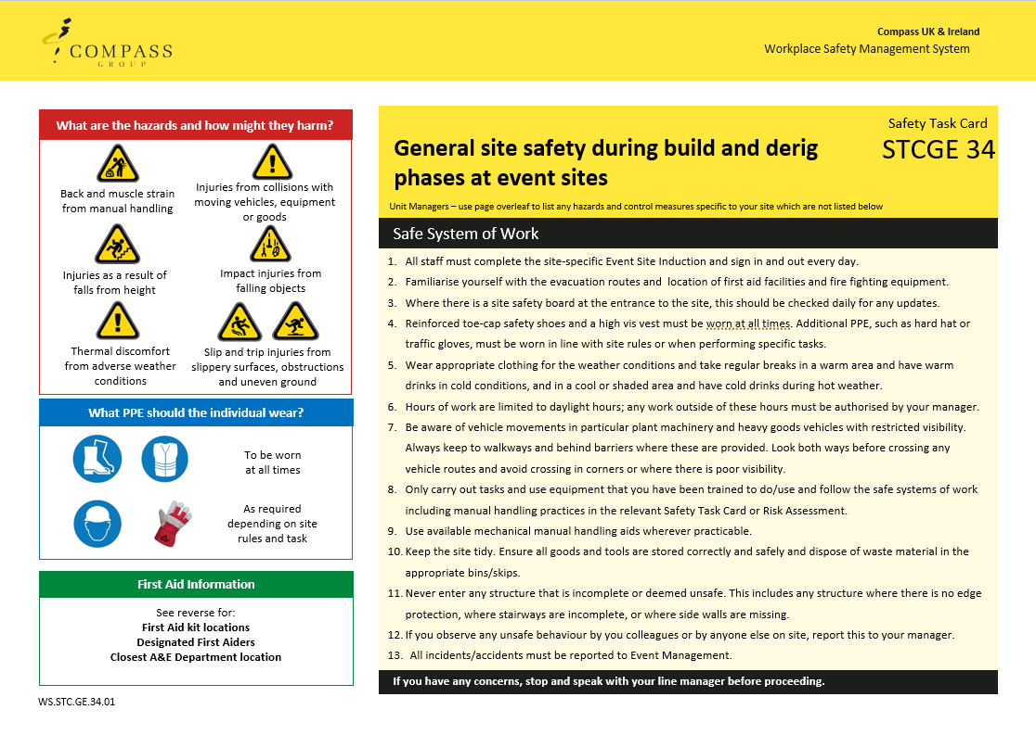
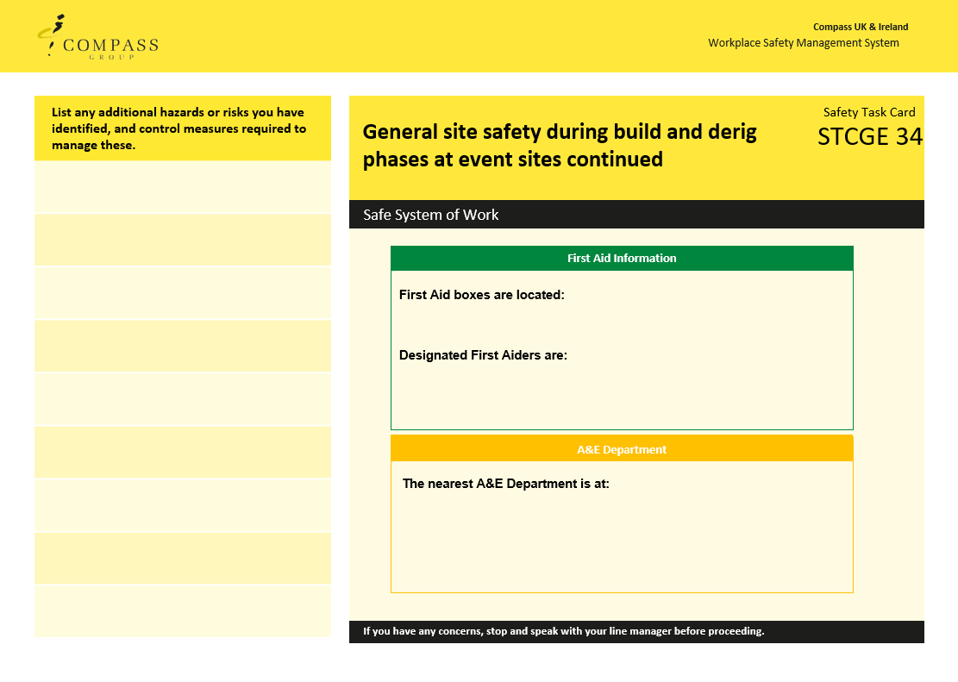

Safe System of Work for Logistics Teams

Safety Risk | Hazard | Related Risk Assessments | Key Control Measures
Cuts | Sharp edges on equipment or packaging  Broken glass and crockery | RA-CS  ES04 | - Always wear rigger or traffi gloves when moving and handling goods and equipment  - If any glassware or crockery shows signs of damage, remove it from service and alert your supervisor  - When clearing broken glass and crockery, always use a dustpan and brush, never pick it up with your bare hands  - Always dispose of the breakages in a designated broken glass and crockery bin or wrap securely in cardboard before placing in general waste.
Slips, Trips and Falls  (Broken bones, bruises, buts) | Wet floors  Cables across walkways  Objects stored in walkways | RA-CS  ES03 | - Always ensure spillages are cleared up immediately  - Make use of wet floor signs and verbally warn others around if you spot a spillage  - Ensure trailing cables are secured to prevent trip hazards  - If you spot something blocking a route, remove it and relocate it to a safer position if you can, alternatively warn others and report to your supervisor
Manual Handling  (Back injuries and muscle strains) | Large items  Repetitive handling  Heavy crockery and equipment  Keg and CO₂ movement | RA-CS  ES04  OP06 | - Ensure that you do not lift or handle anything you do not feel comfortable or capable of doing  - Always wear rigger or traffi gloves when moving and handling goods and equipment  - Always wear re-enforced toe safety footwear when working in logistics  - Always use trolleys, cages or other aids where available  - If using buggies or FLT’s then ensure you have signed off and been authorised in their use, contact your supervisor to facilitate this  - Never stack kegs more than two high, and ensure a keg pallet or solid wooden board between the levels to maintain rigidity and balance  - Always ensure a minimum of two persons lifts a keg and never lift above waist height  - Always ask for assistance from a colleague when needed  - Check the route you are taking before manual handling to ensure it is clear and free of hazards
Chemicals  (Burns and Ingestion/ Inhalation) | Concentrated chemicals | ES05 | - Always wear googles and gloves when handling/ decanting or dispensing concentrated (non-diluted) chemicals  - Never spray chemicals in the direction of colleagues or guests  - Ensure you read the label on the chemical to understand what it should be used for  - Always ensure chemicals are fully sealed before returning to storage areas

Safe System of Work for Logistics Teams

Safety Risk | Hazard | Related Risk Assessments | Key Control Measures
Electrical Safety  (Electric Shock and fire) | Electrical equipment | ES07  RA-CS | - Always ensure electrical equipment is switched off when not needed  - Always switch off equipment before cleaning it  - Never touch electrical equipment or sockets with wet hands  - Always conduct a visual check of equipment before use, check for;  • No obvious damage to the equipment and no loose or missing screws or other fixings  • No burn marks or staining on the wires or around the plugs and sockets  • No coloured wires are visible where the cable is fixed into the plug  • Cables are not damaged with cuts, abrasions or squashed/ trapped under or between heavy furniture or equipment or have tape covering damage and no bent pins of the plug  • Plug and socket have no signs of damage with cracked or broken casings  • All the wires are stored in such a way that they do not cause a trip hazard or can be pulled from the socket or equipment.  - Where equipment is damaged or defective it must be isolated and removed from use with an “Do not use” sign, until repaired by a competent person
LPG and Gas Safety  (Fire and explosion) | LPG cylinders | ES14  RA-CS | - When lighting gas equipment, you must use a long-handled match or taper, do not use a standard cigarette lighter  - If the appliance fails to light first time, turn the gas off to the appliance and allow it to ventilate for at least 3 minutes before attempting to relight it  - Ensure you know the location of the main gas isolation switch for your kitchen, if there is any suspected gas leak or other gas risk, then the gas should be isolated immediately and a gas engineer called. You should then ventilate the area and if needed evacuate the kitchen until a gas engineer can investigate  - Under no circumstances should anyone smoke in the vicinity of the kitchen or LPG Cylinders, designated smoking areas are available  - No combustibles or waste materials should be stored near to the LPG Cylinders  - Under no circumstances should you attempt to interfere with the LPG Cylinder installation, only a GAS SAFE Engineer is allowed to touch or modify the Cylinder installation

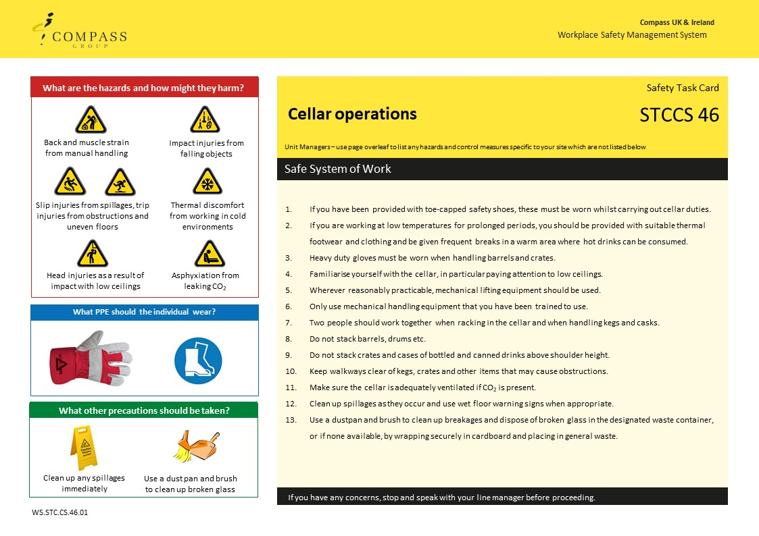
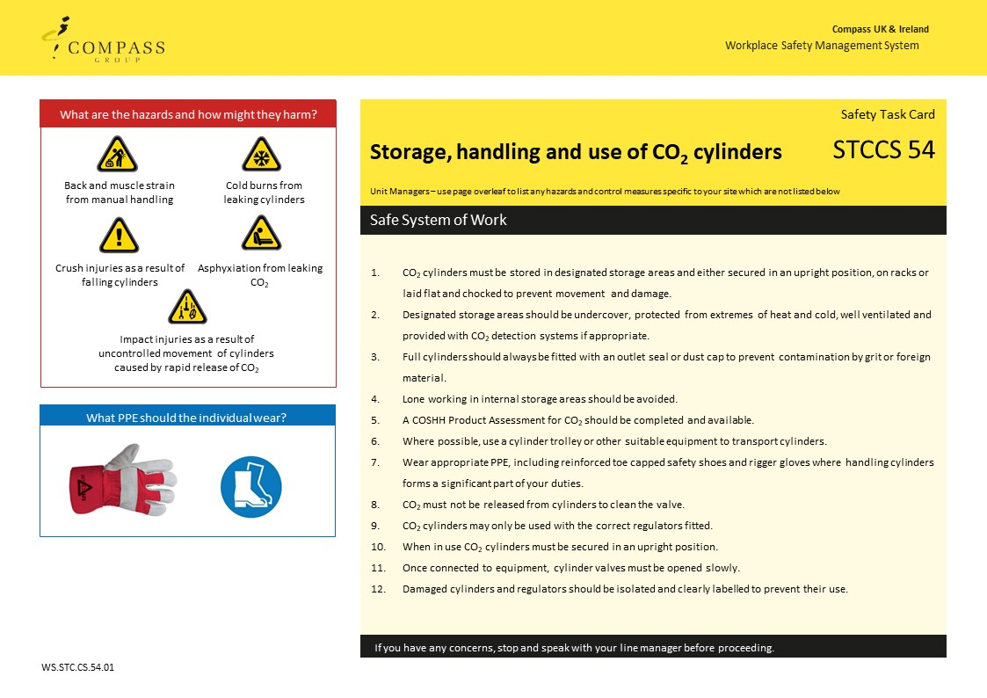
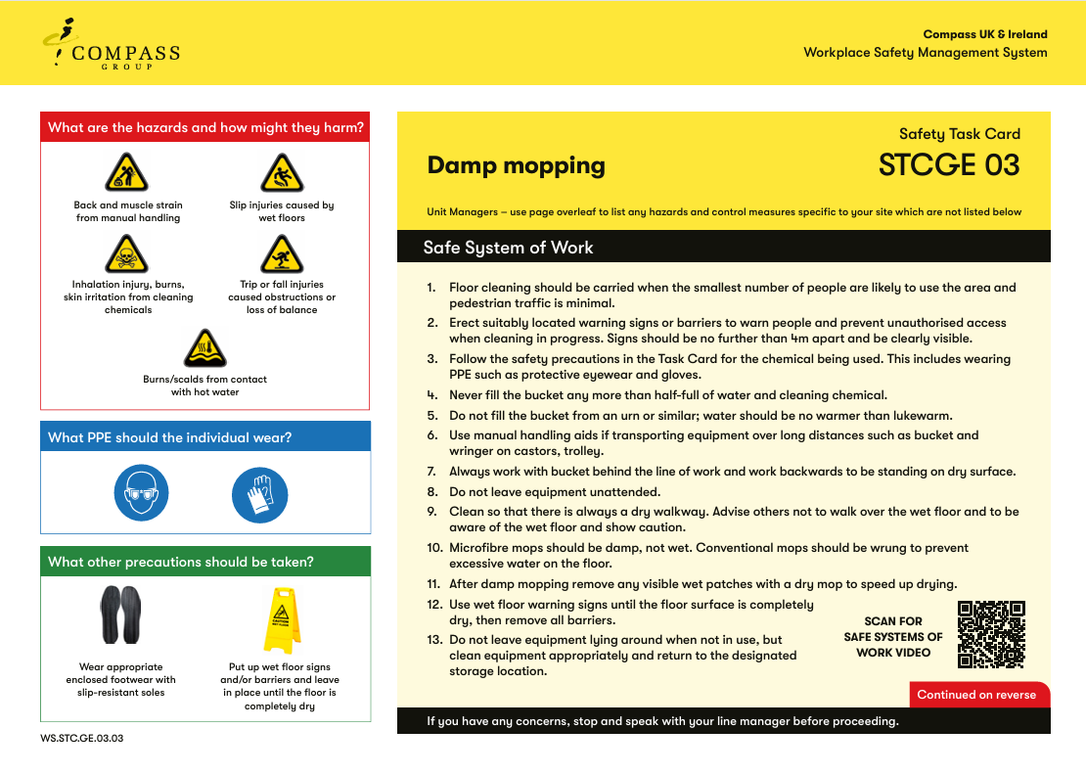
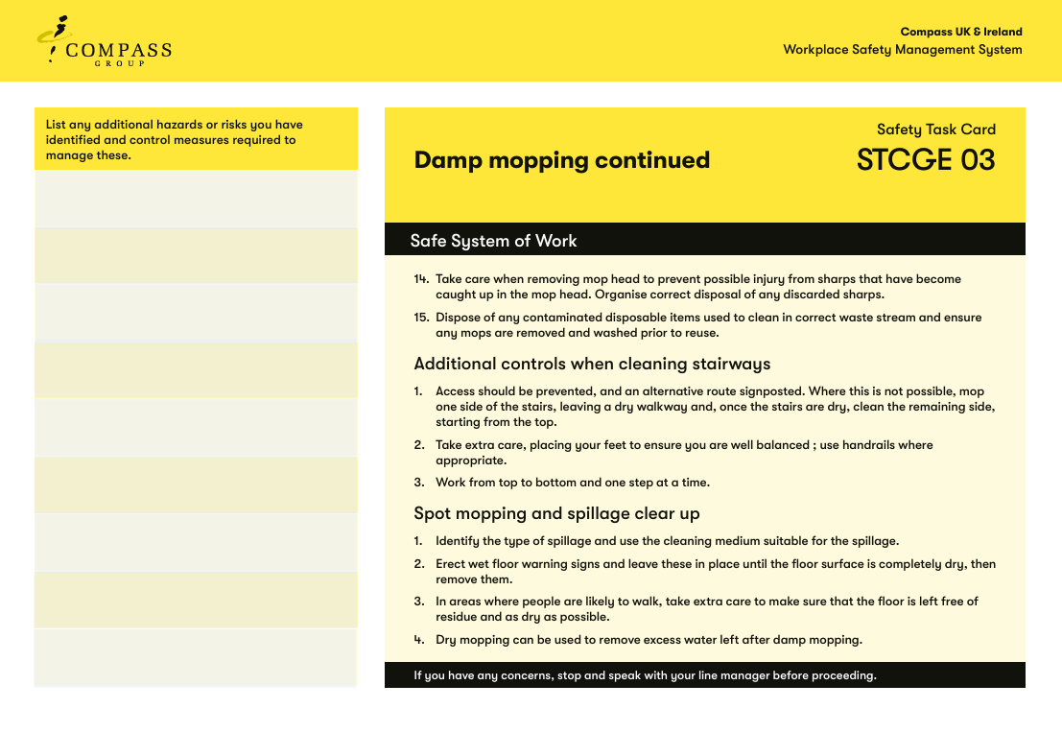
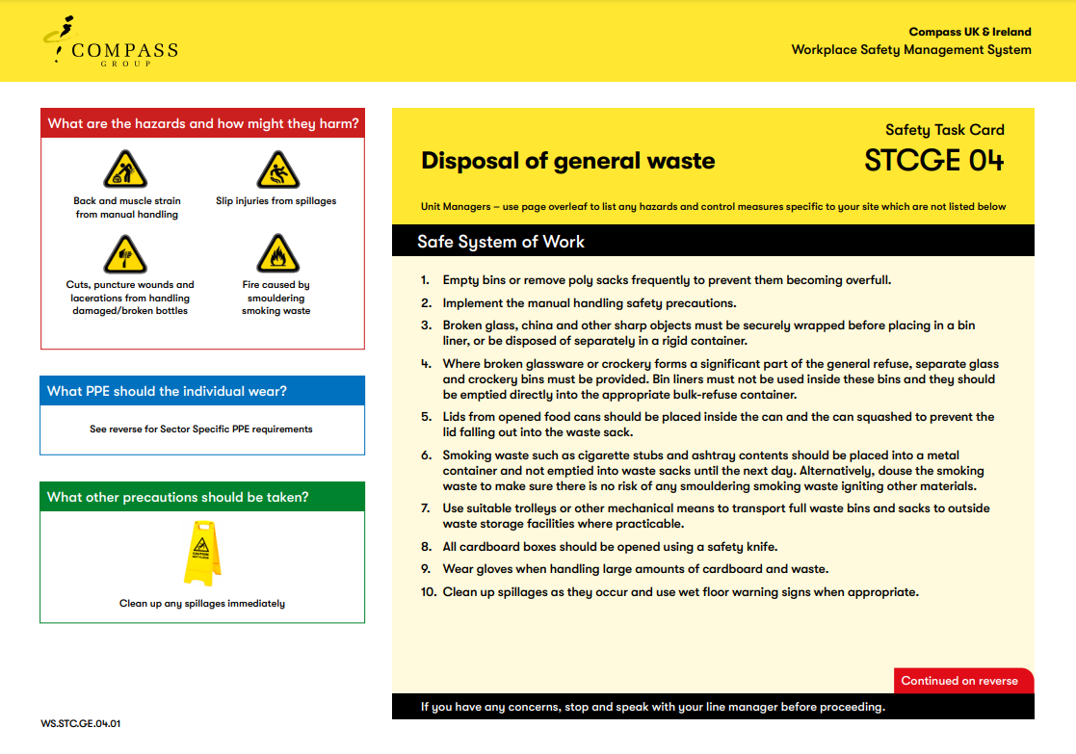
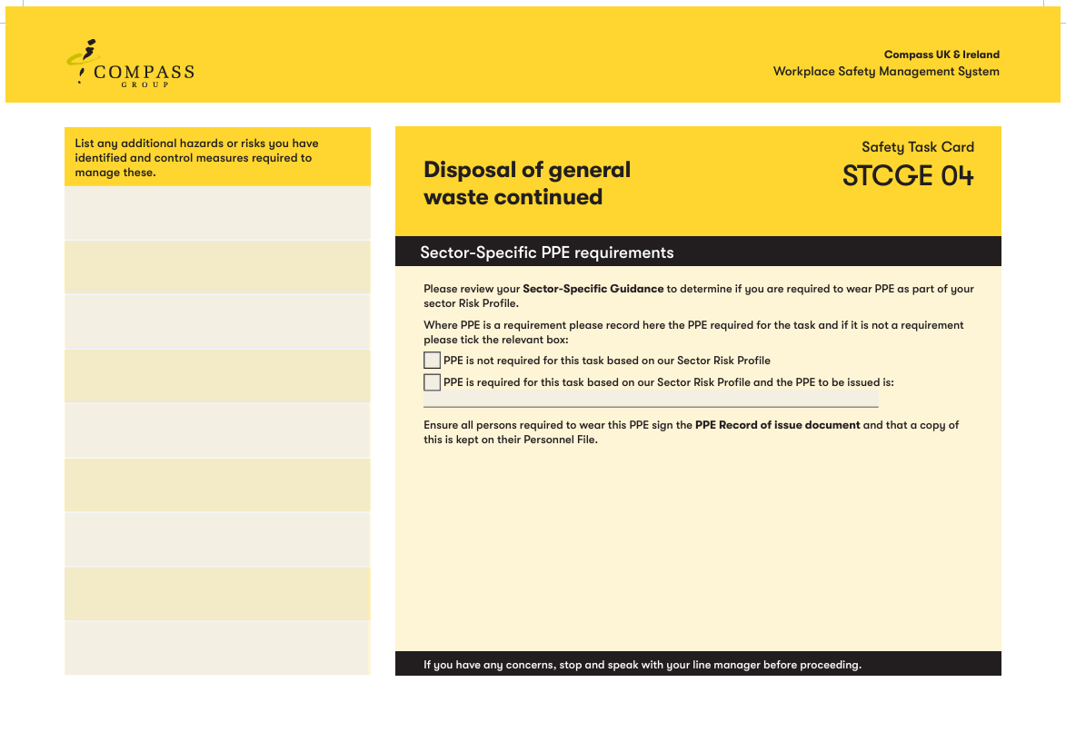
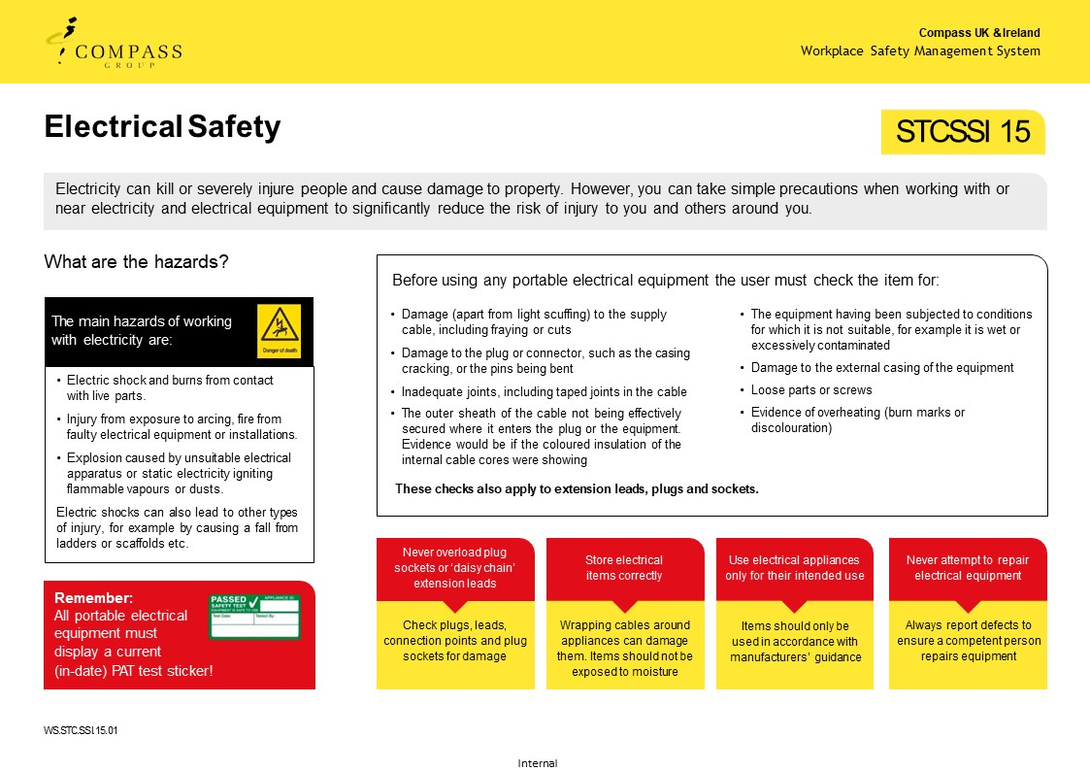
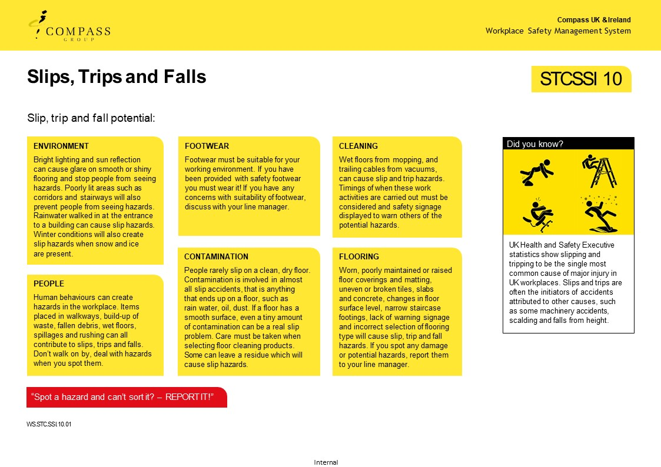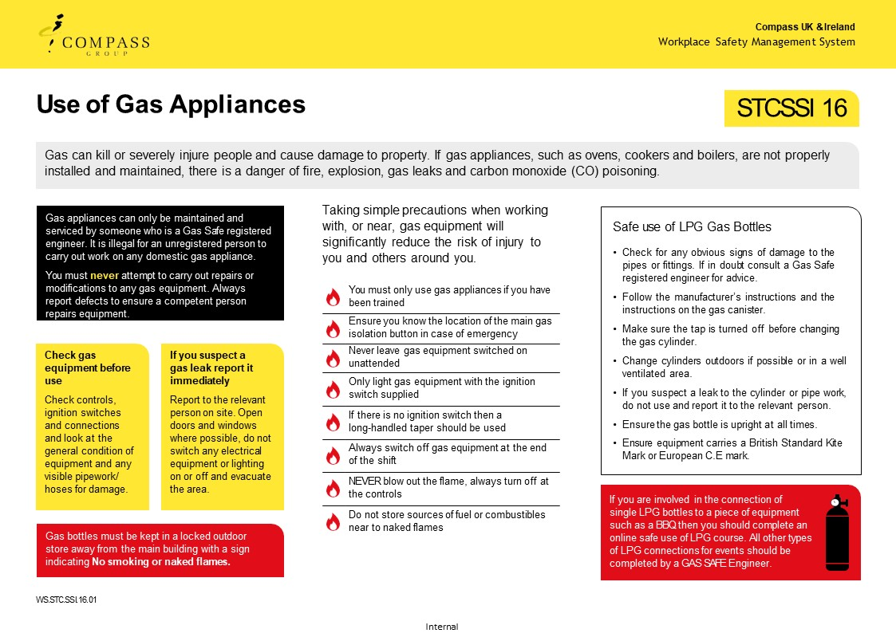
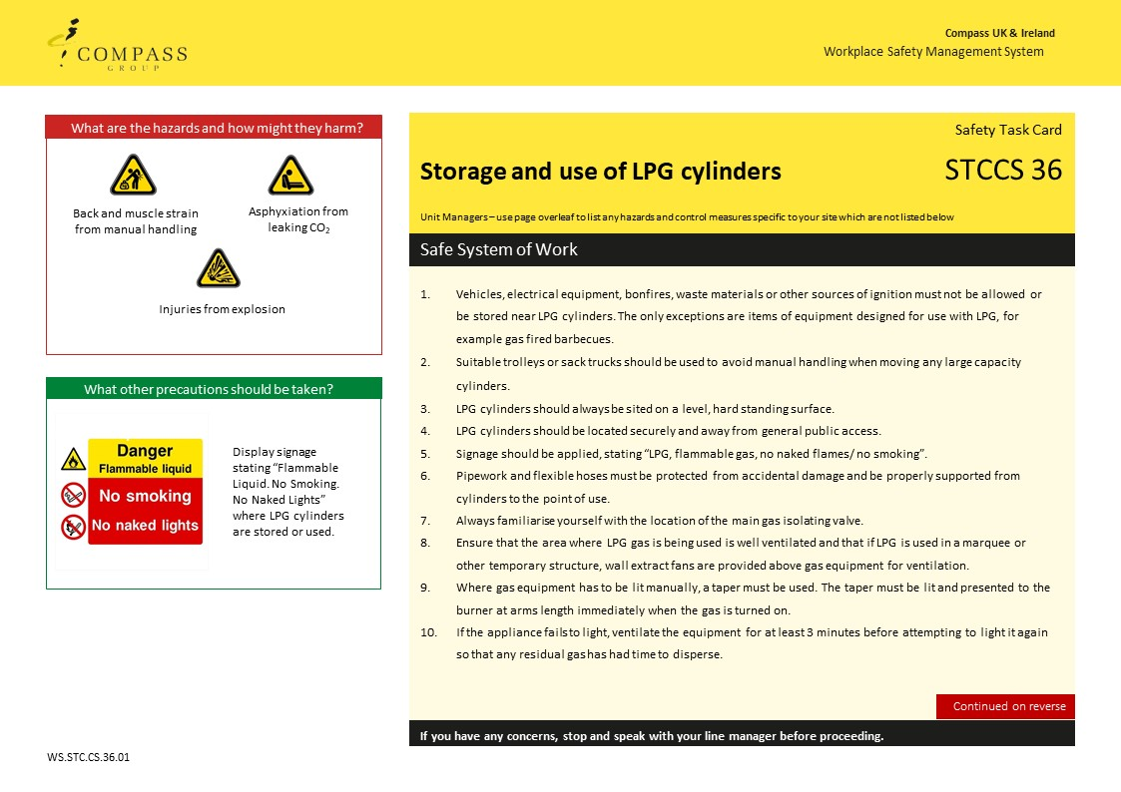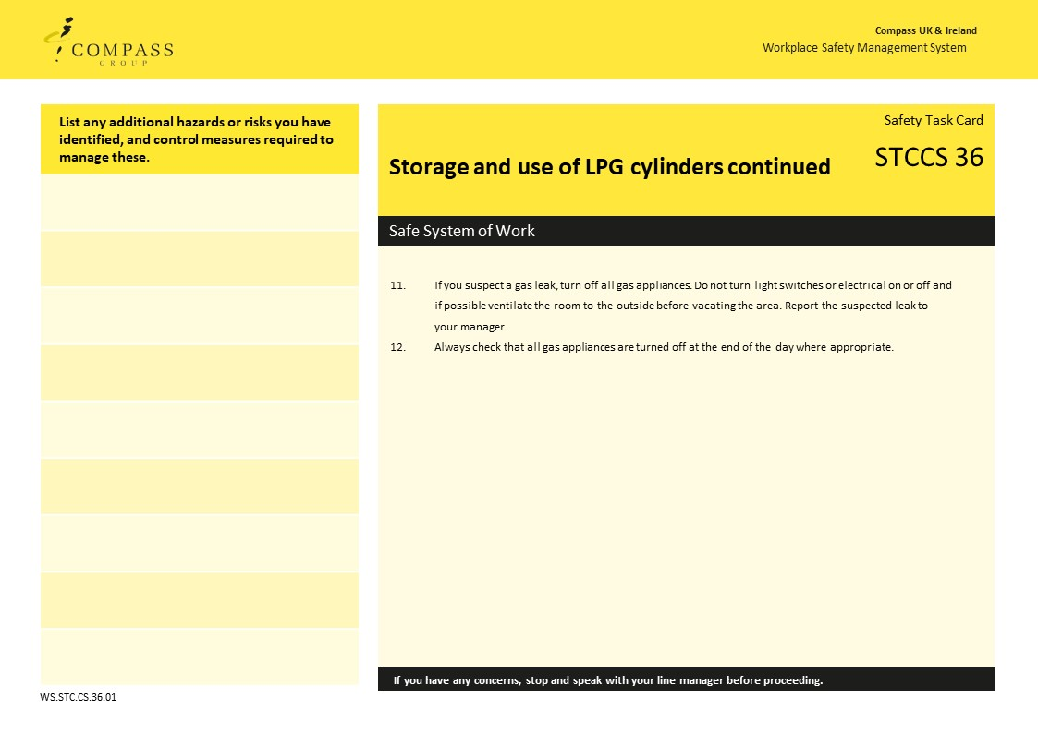
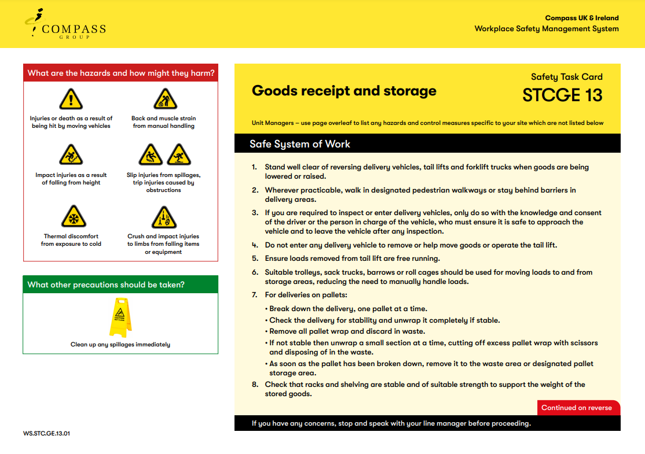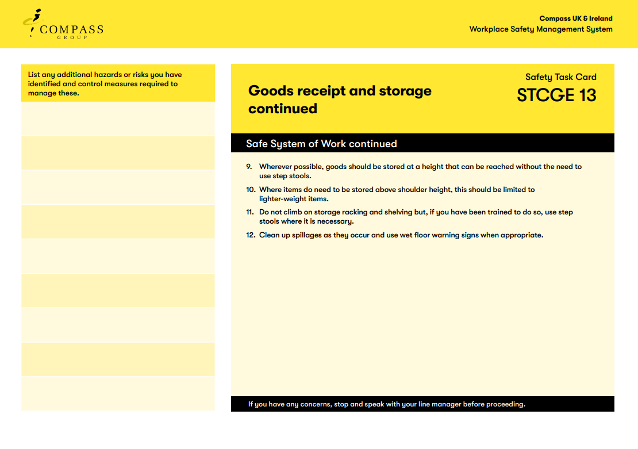
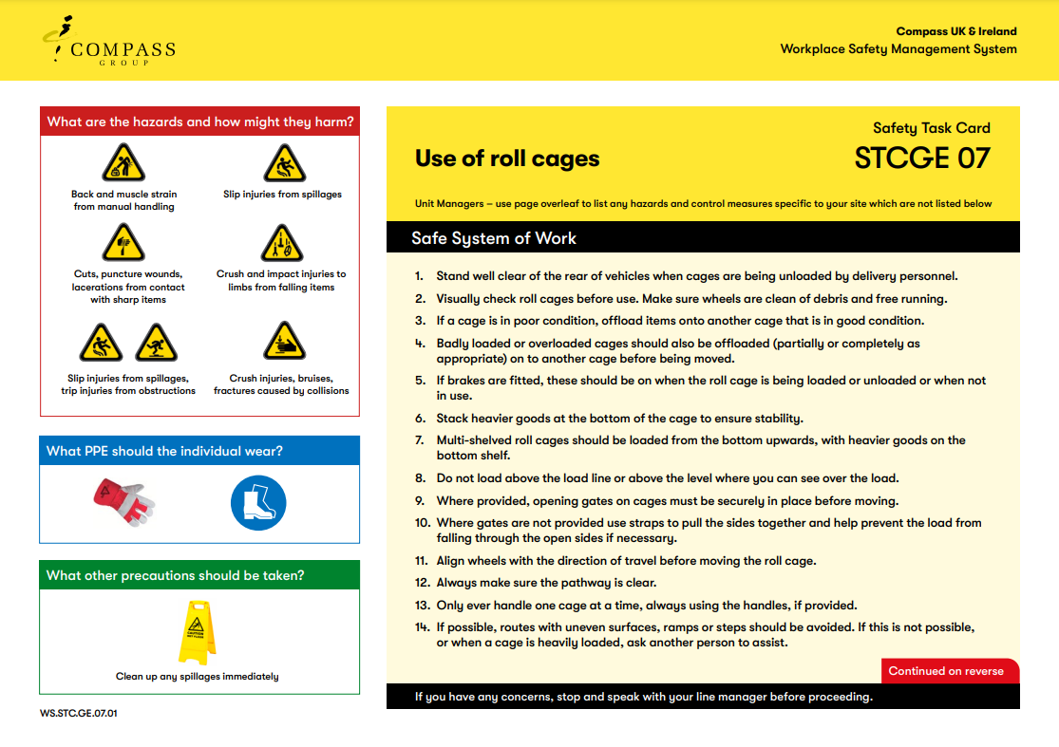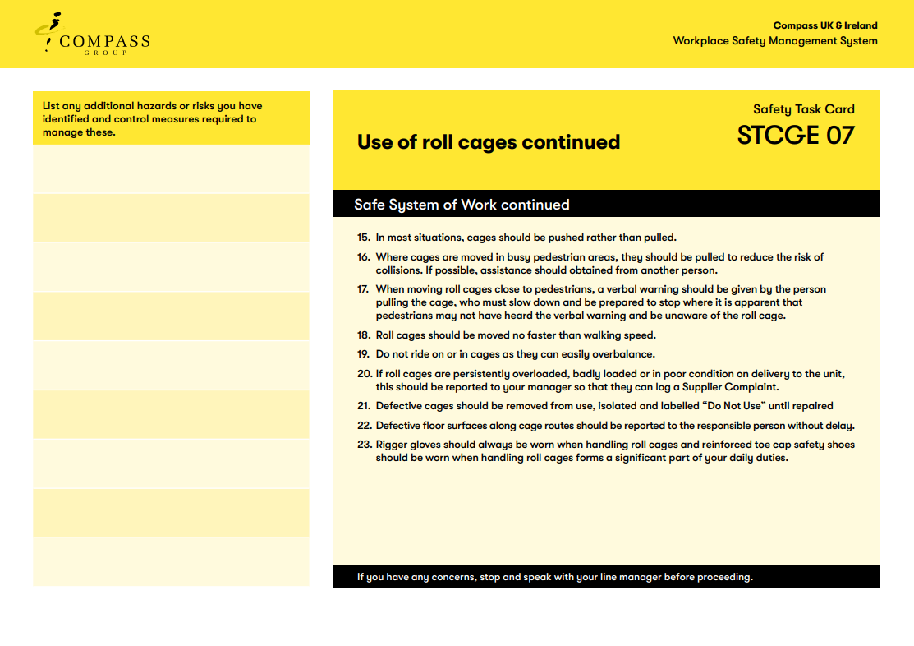
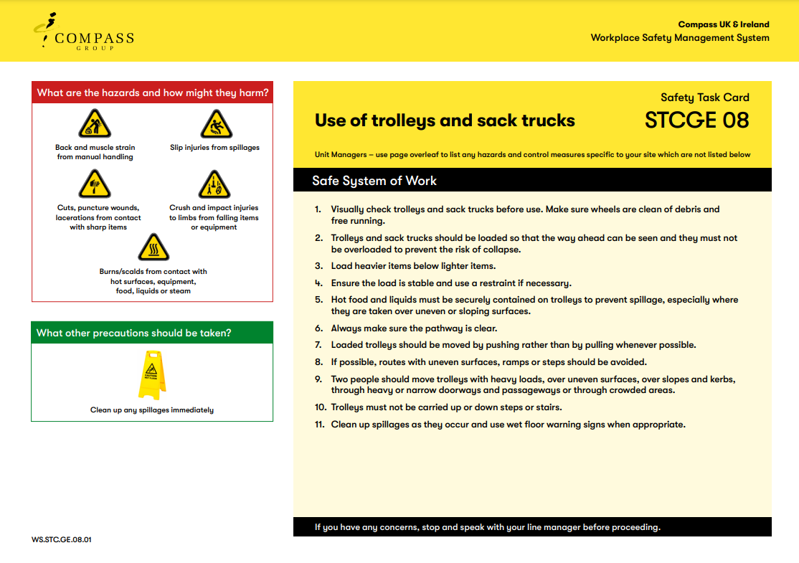
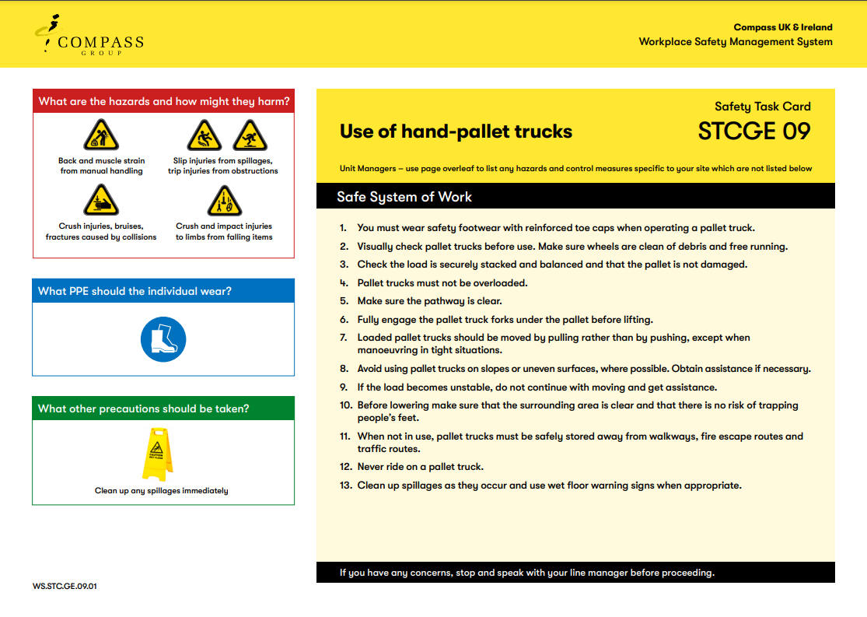
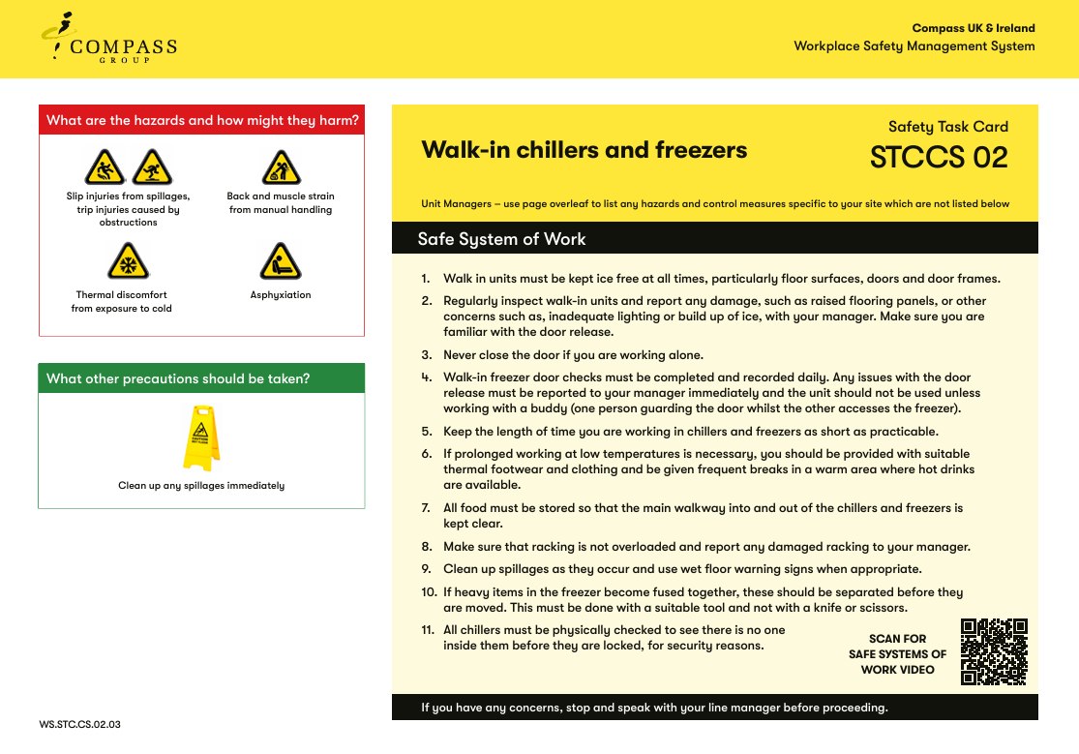
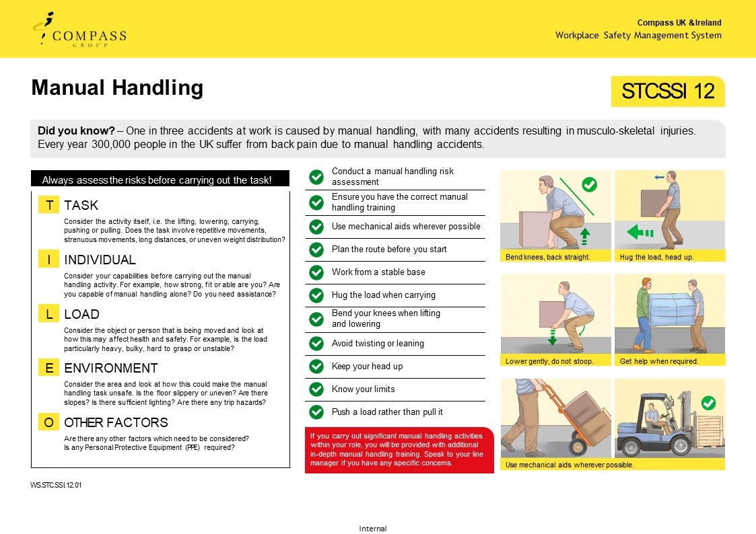

ES04a(i) | Lifting and Carrying Risk Assessment
Unit Name |  | Unit Number
Risk Assessment Completed | Date | Name
Note - Risk assessments must be reviewed every 3 years, whenever there is a significant change in the activity, and following any incident involving the activity. Risk assessments must be retained for a period of 6 years
Task name: |  | Moving and handling CO₂ cylinders
Task description/location: |  | Loading CO₂ cylinders transporting them around the site to chillers and bars.
Step 1 – Assess the task
Do the tasks involve: | YES |  | NO | Problems with the task | Possible remedial actions.  What can be done to help?
- holding loads away from torso? |  |  | X |  | No more than two cylinders to be carried at a time.  Use cages or trolleys to move cylinders between main cellar and location of use.
- twisting? | X
- stooping? | X
- reaching upwards? |  |  | X
- large vertical movement? |  |  | X
- long carrying distances? | X
- strenuous pushing or pulling? |  |  | X
- unpredictable movement of loads? |  |  | X
- repetitive handling? |  |  | X
- insufficient rest or recovery? |  |  | X
- a work rate imposed by a process? |  |  | X
Step 2 – Consider individual capability
Does the job: | YES |  | NO | Problems with the task | Possible remedial actions.  What can be done to help?
- require unusual capability? |  |  | X |  | Ensure manager is aware of pregnancy, disability and of any health problems that may affect ability to carry out task. Consider allocating to other persons in these circumstances.  Ensure all new staff are trained.
- pose a risk to anyone with a health problem? | X
- pose a risk to anyone with a disability? | X
- pose a risk to those who are pregnant? | X
- pose a risk to new/ young people? | X
- require special information/training? |  |  | X

Step 3 – Assess the load
Are the loads: | YES | NO | Problems with the task | Possible remedial actions.  What can be done to help?
- heavy? | X |  |  | Use a pallet truck if moving large volumes of cylinders and ensure load is secured before moving.
- bulky or unwieldy? | X
- difficult to grasp? | X
- unstable or unpredictable? |  | X
- intrinsically harmful e.g. sharp/hot? |  | X

Step 4 – Consider the working environment
Are there: | YES | NO | Problems with the task | Possible remedial actions.  What can be done to help?
- constraints on posture? |  | X |  | Ensure those working externally have been provided with suitable clothing, fleece jackets, riggers gloves, boots.
- uneven/poor quality floor surfaces? | X
- slopes or variations in level? | X
- hot/cold humid conditions?? | X
- strong winds or air movement? |  | X

Step 5 – Consider other factors
Does the job: | YES | NO | Problems with the task | Possible remedial actions.  What can be done to help?
- require any PPE? | X |  |  | All logistics persons to be wearing re-enforced toe safety footwear and rigger gloves.
- Require any additional considerations not covered in the above? | X |  |  | Task to be carried out when pedestrian traffic is minimal.

Step 6 – Action plan
Action to be taken | By whom? | By when? | Completed Y/N

ES04a(ii) | Lifting and Carrying Risk Assessment
Unit Name |  | Unit Number
Risk Assessment Completed | Date | Name
Note - Risk assessments must be reviewed every 3 years, whenever there is a significant change in the activity, and following any incident involving the activity. Risk assessments must be retained for a period of 6 years
Task name: |  | Moving crates of crockery and stock around site
Task description/location: |  | Transporting goods around the site.
Step 1 – Assess the task
Do the tasks involve: | YES |  | NO | Problems with the task | Possible remedial actions.  What can be done to help?
- holding loads away from torso? |  |  | X |  | No more than two crates to be lifted at once.  Use cages or trolleys to move crates over long distances.  Get assistance to load heavy items onto cages and trolleys.
- twisting? | X
- stooping? | X
- reaching upwards? |  |  | X
- large vertical movement? |  |  | X
- long carrying distances? | X
- strenuous pushing or pulling? |  |  | X
- unpredictable movement of loads? |  |  | X
- repetitive handling? |  |  | X
- insufficient rest or recovery? |  |  | X
- a work rate imposed by a process? |  |  | X
Step 2 – Consider individual capability
Does the job: | YES |  | NO | Problems with the task | Possible remedial actions.  What can be done to help?
- require unusual capability? |  |  | X |  | Ensure manager is aware of pregnancy, disability and of any health problems that may affect ability to carry out task. Consider allocating to other persons in these circumstances.  Ensure all new staff are trained.
- pose a risk to anyone with a health problem? | X
- pose a risk to anyone with a disability? | X
- pose a risk to those who are pregnant? | X
- pose a risk to new/ young people? | X
- require special information/training? |  |  | X

Step 3 – Assess the load
Are the loads: | YES | NO | Problems with the task | Possible remedial actions.  What can be done to help?
- heavy? | X |  |  | Use pallet truck if moving large pallets crates ensure they are secured.
- bulky or unwieldy? | X
- difficult to grasp? | X
- unstable or unpredictable? |  | X
- intrinsically harmful e.g. sharp/hot? |  | X

Step 4 – Consider the working environment
Are there: | YES | NO | Problems with the task | Possible remedial actions.  What can be done to help?
- constraints on posture? |  | X |  | Plan route to avoid slopes and uneven surfaces where possible.
- uneven/poor quality floor surfaces? | X
- slopes or variations in level? | X
- hot/cold humid conditions?? | X
- strong winds or air movement? |  | X

Step 5 – Consider other factors
Does the job: | YES | NO | Problems with the task | Possible remedial actions.  What can be done to help?
- require any PPE? | X |  |  | All logistics persons to be wearing re-enforced toe safety footwear and rigger gloves.
- Require any additional considerations not covered in the above? | X |  |  | Task to be carried out when pedestrian traffic is minimal.

Step 6 – Action plan
Action to be taken | By whom? | By when? | Completed Y/N

ES04a(iii) | Lifting and Carrying Risk Assessment
Unit Name |  | Unit Number
Risk Assessment Completed | Date | Name
Note - Risk assessments must be reviewed every 3 years, whenever there is a significant change in the activity, and following any incident involving the activity. Risk assessments must be retained for a period of 6 years
Task name: |  | Handling and moving keg
Task description/location: |  | Loading keg, transporting it around the site and delivering it to chillers and bars.
Step 1 – Assess the task
Do the tasks involve: | YES |  | NO | Problems with the task | Possible remedial actions.  What can be done to help?
- holding loads away from torso? |  |  | X |  | Two persons to lift full kegs.  Use kegs trolley to move kegs between main cellar and location of use.
- twisting? | X
- stooping? | X
- reaching upwards? |  |  | X
- large vertical movement? |  |  | X
- long carrying distances? | X
- strenuous pushing or pulling? |  |  | X
- unpredictable movement of loads? |  |  | X
- repetitive handling? |  |  | X
- insufficient rest or recovery? |  |  | X
- a work rate imposed by a process? |  |  | X
Step 2 – Consider individual capability
Does the job: | YES |  | NO | Problems with the task | Possible remedial actions.  What can be done to help?
- require unusual capability? |  |  | X |  | Ensure manager is aware of pregnancy, disability and of any health problems that may affect ability to carry out task. Consider allocating to other persons in these circumstances.  Ensure all new staff are trained.
- pose a risk to anyone with a health problem? | X
- pose a risk to anyone with a disability? | X
- pose a risk to those who are pregnant? | X
- pose a risk to new/ young people? | X
- require special information/training? |  |  | X

Step 3 – Assess the load
Are the loads: | YES | NO | Problems with the task | Possible remedial actions.  What can be done to help?
- heavy? | X |  |  | Use a pallet truck if moving large pallets of kegs.  Do not stack kegs more than two high and always use a keg pallet between keg stacks.
- bulky or unwieldy? | X
- difficult to grasp? | X
- unstable or unpredictable? |  | X
- intrinsically harmful e.g. sharp/hot? |  | X

Step 4 – Consider the working environment
Are there: | YES | NO | Problems with the task | Possible remedial actions.  What can be done to help?
- constraints on posture? |  | X |  | Plan route to avoid slopes and uneven surfaces where possible.  Ensure those working externally have been provided with suitable clothing, fleece jackets, riggers gloves, boots.
- uneven/poor quality floor surfaces? | X
- slopes or variations in level? | X
- hot/cold humid conditions?? | X
- strong winds or air movement? |  | X

Step 5 – Consider other factors
Does the job: | YES | NO | Problems with the task | Possible remedial actions.  What can be done to help?
- require any PPE? | X |  |  | All logistics persons to be wearing re-enforced toe safety footwear and rigger gloves.
- Require any additional considerations not covered in the above? | X |  |  | Task to be carried out when pedestrian traffic is minimal.

Step 6 – Action plan
Action to be taken | By whom? | By when? | Completed Y/N

ES04a(iv) | Lifting and Carrying Risk Assessment
Unit Name |  | Unit Number
Risk Assessment Completed | Date | Name
Note - Risk assessments must be reviewed every 3 years, whenever there is a significant change in the activity, and following any incident involving the activity. Risk assessments must be retained for a period of 6 years
Task name: |  | Receiving goods and deliveries
Task description/location: |  | Transporting deliveries and goods to stores.
Step 1 – Assess the task
Do the tasks involve: | YES |  | NO | Problems with the task | Possible remedial actions.  What can be done to help?
- holding loads away from torso? |  |  | X |  | Use a pallet truck or trolley to transfer goods from delivery area to stores.  Only trained persons to use the pallet truck.  Get assistance to load heavy items onto trolleys.
- twisting? | X
- stooping? | X
- reaching upwards? |  |  | X
- large vertical movement? |  |  | X
- long carrying distances? | X
- strenuous pushing or pulling? |  |  | X
- unpredictable movement of loads? |  |  | X
- repetitive handling? |  |  | X
- insufficient rest or recovery? |  |  | X
- a work rate imposed by a process? |  |  | X
Step 2 – Consider individual capability
Does the job: | YES |  | NO | Problems with the task | Possible remedial actions.  What can be done to help?
- require unusual capability? |  |  | X |  | Ensure manager is aware of pregnancy, disability and of any health problems that may affect ability to carry out task. Consider allocating to other persons in these circumstances.  Ensure all new staff are trained.
- pose a risk to anyone with a health problem? | X
- pose a risk to anyone with a disability? | X
- pose a risk to those who are pregnant? | X
- pose a risk to new/ young people? | X
- require special information/training? |  |  | X

Step 3 – Assess the load
Are the loads: | YES | NO | Problems with the task | Possible remedial actions.  What can be done to help?
- heavy? | X |  |  | Either get assistance to lift heavy items onto and off trolleys or split load into smaller sizes/quantities before moving
- bulky or unwieldy? | X
- difficult to grasp? | X
- unstable or unpredictable? |  | X
- intrinsically harmful e.g. sharp/hot? |  | X

Step 4 – Consider the working environment
Are there: | YES | NO | Problems with the task | Possible remedial actions.  What can be done to help?
- constraints on posture? |  | X |  | Plan route to avoid slopes and uneven surfaces where possible.  Ensure those working externally have been provided with suitable clothing, fleece jackets, riggers gloves, boots.
- uneven/poor quality floor surfaces? | X
- slopes or variations in level? | X
- hot/cold humid conditions?? | X
- strong winds or air movement? |  | X

Step 5 – Consider other factors
Does the job: | YES | NO | Problems with the task | Possible remedial actions.  What can be done to help?
- require any PPE? | X |  |  | All logistics persons to be wearing re-enforced toe safety footwear and rigger gloves.
- Require any additional considerations not covered in the above? | X |  |  | Task to be carried out when pedestrian traffic is minimal.

Step 6 – Action plan
Action to be taken | By whom? | By when? | Completed Y/N

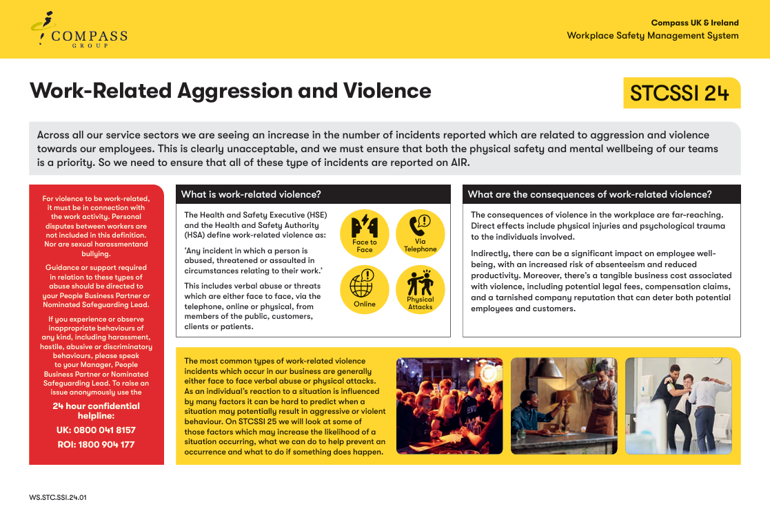
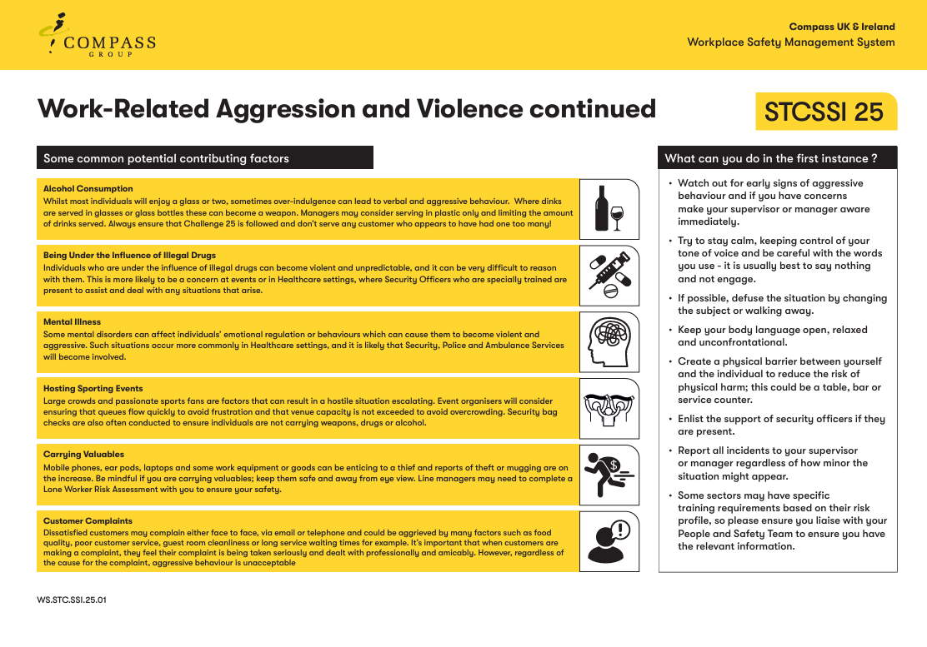

EMPLOYEE RECORD OF SAFETY BRIEFING
Unit Name: |  | Date of Briefing:
Event Name: |  | Briefing Conducted By:
By signing below, I confirm that I have been briefed on the above safety information covering Fire & Emergency, Infection Control and Safe Systems of Work for Logistics. I understand it is my responsibility to follow instructions, to work safely and only to do work that I have been trained to do or that I am being trained on or supervised whilst doing. I also understand that I can ask my manager or supervisor at any time if I am unsure of what to do. I also confirm that I have not been suffering from any sickness or diarrhoea in the last 48 hours

Name | Signature |  | Date

