Banksman E-learning Course authorisation form

Course Attendee’s Full Name
Email Address
Unit Number
Cost Centre
HSE Manager’s Name
Line Manager’s Name and Signature

The programme will cost £30.00 (incl VAT) which will be cross charged to your Cost Centre.
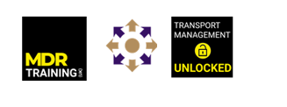
Please return the complete form to HSECourses@compass-group.co.uk

