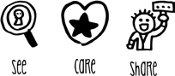
Compass UK & Ireland

Workplace Safety Management System

ES04 | Manual Handling – Activity Filter
Unit Name |  | Unit Number
Risk Assessment Completed | Date | Signed
1st review | Date | Signed
2nd review | Date | Signed
3rd review | Date | Signed
Note - Risk assessments must be reviewed every 3 years, whenever there is a significant change in the activity, and following any incident involving the activity. Risk assessments must be retained for a period of 6 years.

Step 1 - Identify manual handling activities undertaken in the unit or workplace (list below each that applies)
For each activity, consider steps 2-4. Where the risk is not LOW, add the activity to the right-hand box.
Examples include:
Stacking/unstacking items, pushing roll cages, oven racks, jack stacks and trolleys, handling food, drink and non-food containers, handling furniture and equipment, operating/using work equipment, handling portable work equipment.
Step 2 – Lifting and Lowering
- Can the load be grasped with both hands? YES NO  - Are the working conditions reasonable? YES NO  - Can the load be lifted from a stable body YES NO  position?  - Does the handling involve torso twisting? NO YES  - Is the handling more frequent than one lift NO YES  every two minutes?  - Is the handling done by a team together? NO YES  - Do the weights of the load vary from start to NO YES  finish?  - Is the person lifting at significant risk e.g. new NO YES  or expectant mother, young worker, disability,  health problem, recent injury?  - From the guidelines on p3, does the weight of NO YES  the load exceed the value for lifting and lowering  in that zone?  Lifting and lowering risk is considered LOW | Manual handling activities involving lifting and lowering that require risk assessment (ES04a)

Document Name | Manual Handling Activity Filter | Document No | WS.RA.ES.04.01
Document Owner | Workplace Safety | Date of Issue | July 2022
Classification | Internal Use | Version No | 1.0
Page 1 of 3

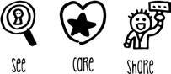
Compass UK & Ireland

Workplace Safety Management System

Step 3 – Carrying
- Is the load held against the body? YES NO  - Is it carried no further than 10m without NO YES  resting?  - Does carrying the load prevent the person from NO YES  walking normally?  - Does carrying the load obstruct the view of the NO YES  person carrying it?  - From the guidelines on p3, does the weight of NO YES  the load exceed the value during carrying?  Carrying risk is considered LOW | Manual handling activities involving carrying that require risk assessment (ES04a)
Step 4 – Pushing and Pulling
- Can the load be moved and controlled easily, YES NO  for example by one hand?  - Is the pushing and pulling force applied by the YES NO  hands?  - Is the torso largely upright and not twisted? YES NO  - Are the hands between hip and shoulder YES NO  height?  - Is the distance moved without a pause or break YES NO  no more than about 20m?  - Does the person’s posture indicate significant NO YES  force is required? Compare with diagrams on p3.  - Are there extra risk factors such as slopes, NO YES  uneven floors, constricted spaces or trapping  hazards?  Pushing and pulling risk is considered LOW | Manual handling activities involving pushing and pulling that require risk assessment (ES04b)
Manual handling activity filter:

Lifting and Carrying
Lifting and lowering Carrying Risk Assessment LOW LOW (ES04a)
NOT REQUIRED

Pushing and Pulling
Pushing and pulling Risk Assessment LOW (ES04b)
NOT REQUIRED

Document Name | Manual Handling Activity Filter | Document No | WS.RA.ES.04.01
Document Owner | Workplace Safety | Date of Issue | July 2022
Classification | Internal Use | Version No | 1.0
Page 2 of 3

Page 3 of 3
Document Name | Manual Handling Activity Filter | Document No | WS.RA.ES.04.01
Document Owner | Workplace Safety | Date of Issue | July 2022
Classification | Internal Use | Version No | 1.0

Compass UK & Ireland
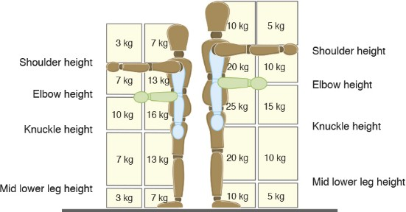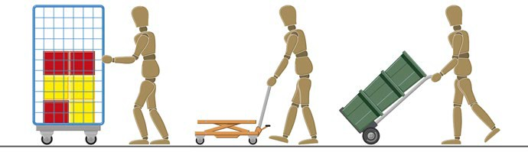Workplace Safety Management System
Acceptable Push/Pull Postures
Manual Handling Weight Guidelines

These guidelines are not ‘safe limits’ for lifting and carrying. They use broad assumptions where, if met, the risk of injury is considered to be low. Working outside these limits is likely to increase the risk of injury.

