Welcome to Lifecycle Oils

Dear Compass Customer,

We are thrilled to announce that Lifecycle Oils are now your new Used Cooking Oil (UCO) collector. We are committed to providing you with the highest quality service to meet your needs.

At Lifecycle Oils, we believe in building long-term relationships with our customers. We are dedicated to providing you with the best possible experience and ensuring that you receive the highest level of customer service.

Please find attached the documentation that you may require from Lifecycle Oils. If you have any questions or concerns, please do not hesitate to contact us.

We look forward to working with you and building a long-lasting relationship.

Sincerely,
LCO

CONTACT LIST

All Customer Services:

Call us on 01922 903388 between 9:00am to 5:00pm

e-mail us at customer.service@lifecycleoils.com.

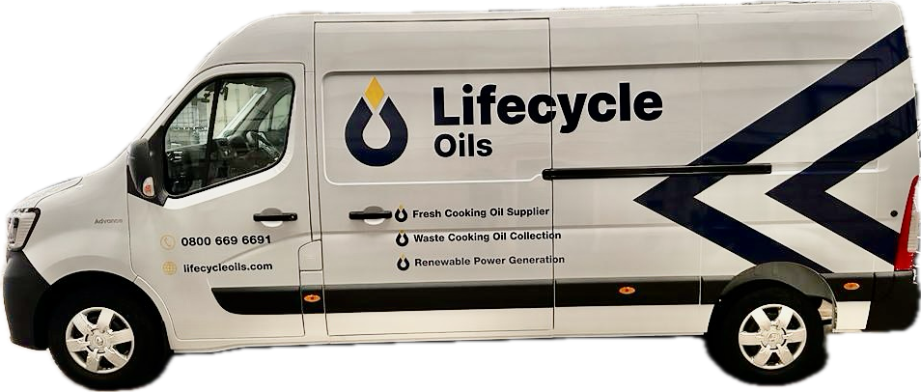

Documents List

Documents | Attachments
Copy of the full permit issued by the authorities listing permitted wastes or equivalent license issued by local council
Copy of Exemptions if applicable

Copy of waste carrier's license
Copy of the environmental policy statement
Insurance & Liability certificates -
Latest CAR report issued by authorities
Calibration/weighbridge certification
Training/qualification certification
H&S Policy Statement
SML Delivery / Collection Risk Assessment/RAMS

